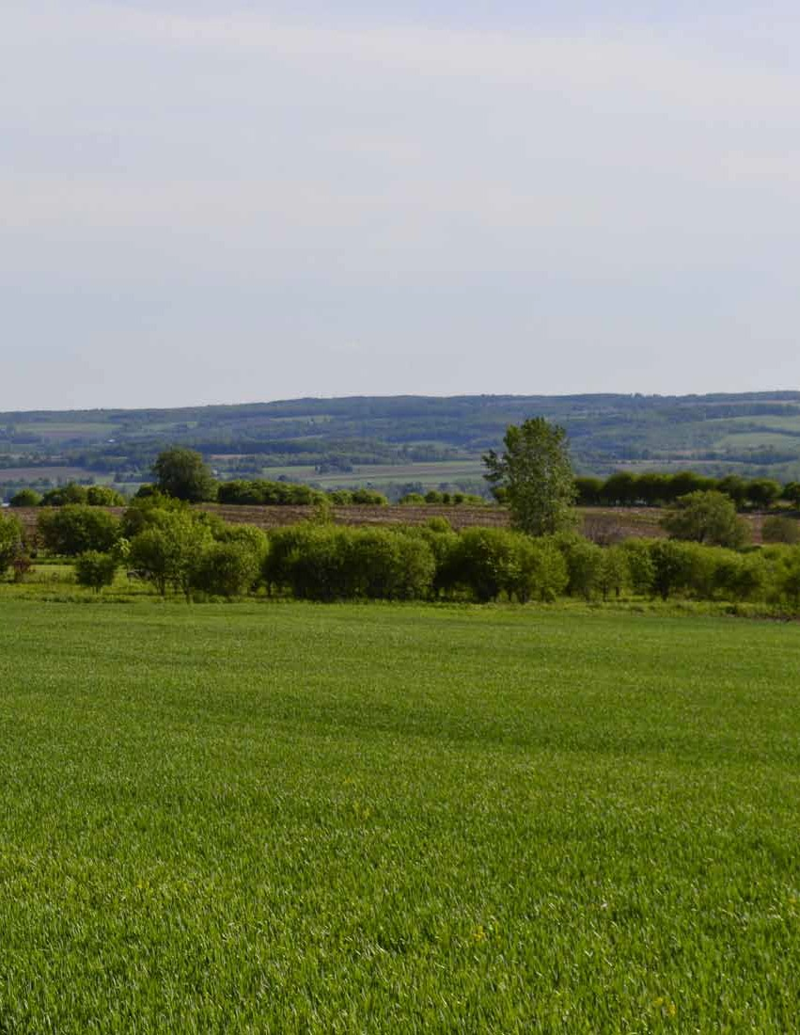
Town of Skaneateles

Open Space Plan
October 19, 2016

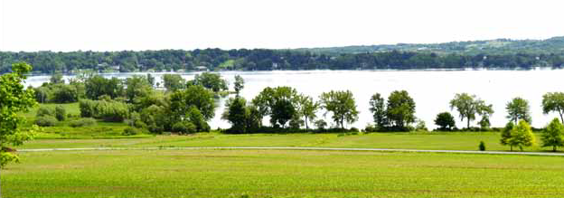

EXECUTIVE SUMMARY
The Skaneateles Open Space Committee established a partnership with the Central New York Regional Planning and Development Board (CNY RPDB) in order to compile this Open Space Plan. The
Committee goals were to identify and prioritize land parcels for open space conservation and to develop recommendations that would protect natural and cultural resources, support agricultural sustainability, and protect Skaneateles Lake water quality. The recommendations are designed to promote wise land use decisions regarding the future of open space in Skaneateles and the report is intended to serve as a living document that can be referenced and updated in the coming years.

The Open Space Plan was completed in cooperation with public and private partners including elected officials, residents, farmers, and agency representatives. The recommendations focus on land use practices that will reduce urban sprawl and haphazard or arbitrary growth that can negatively impact open space resources. The report promotes the protection of scenic views, agricultural lands, forests, lake water quality, historic sites, wildlife habitats, and critical environmental areas.

The following goals were established as part of the Open Space Plan:
- Preserve and protect areas with natural and cultural significance
- Protect water resources
- Provide opportunities for a long-term mechanism to finance open space preservation
- Protect valuable farmland and the rural agrarian landscape
- Maintain a network of pedestrian and recreational trails
- Provide educational opportunities for diverse target groups

Development of the Open Space Plan was grassroots initiative that provided an opportunity to identify unique and valued resources throughout the community and to present cost effective tools and methods to protect them. It also provided a valuable opportunity to maintain open lines of communication among community groups. Now that the Plan has been completed, a priority goal for the committee is to implement the high priority recommendations. Several are summarized on the following page.

- The Open Space Committee supports the use of conservation easements and other preservation tools that will direct development away from valued agricultural and open space parcels and towards priority areas for new investment. An open dialog between the farming community, municipal representatives, Onondaga County, and New York State agencies will strengthen these efforts.
- The Skaneateles Open Space Conservation Land Prioritization model was developed to identify, map, and prioritize valued sites for conservation purposes. Use of the resulting map (found on page 38) is just one of several tools that can be applied to prioritize parcels for conservation. Additional parcels have also been identified as valuable for conservation based on factors such as availability and cost. Continued implementation of conservation measures for these parcels should continue.
- Municipal representatives and stakeholders are encouraged to continue the development of an interconnecting network of trails and bikeways that incorporate natural features such as the Skaneateles Creek corridor, segments of the lake shore, and stream corridors.
- The Town currently maintains an Open Space Fund to support open space conservation efforts. The Open Space Committee established guidelines in 2010 for the prioritization of land owners to receive this funding. Financial support for landowners to help with transfer fees would be a worthwhile use of the funds. The methodology used for the selection of recipients should be updated based on current priorities for open space. The availability and intended use of the Open Space Fund should be publicized, and financial and land donations from the public should be encouraged.
- A stronger effort is needed to pursue funding for conservation purposes such as grant applications submitted to the New York State farmland protection program.
- A comprehensive, dedicated funding mechanism is needed such as a real estate transfer tax that could provide up to 2% on conveyances of residential property for open space, recreation, and farmland protection.
- In order to protect water quality in Skaneateles Lake (which serves as a valuable drinking water source for Syracuse and neighboring communities) the City of Syracuse, the State of New York, the federal government, and the private sector are encouraged to resume a program to secure land in the Skaneateles Lake watershed through the acquisition of conservation easements.
- The town is encouraged to collaborate with local land trusts such as the Finger Lakes Land Trust and the Central New York Land Trust to purchase and sustain parcels in permanent conservation. Options to establish a local land trust in Skaneateles should also be developed.
- The continued installation of green infrastructure in contribution areas near the lake and its tributaries is needed to reduce the amount of stormwater runoff. Improvements in the capacity of stormwater collection systems and agricultural Best Management Practices are especially important when dealing with the increasing frequency and intensity of storm events.

This report was compiled by the Central New York Regional Planning and Development Board in cooperation with the Skaneateles Open Space Committee.

TAblE Of COnTEnTS

EXECUTIVE SUMMARY 3
Chapter 1: Introduction. 8
Statement of Purpose. 8
Benefits of an Open Space Plan. 9
Legislative Basis for Open Space. 9
The Value of Open Space. 9
Local Efforts to Protect Open Space. 10
The Skaneateles Open Space Planning Process. 10
Planning Partners. 12
Chapter 2: Open Space Goals and Objectives. 15
Valued Resources and Characteristics. 15
Issues of Concern. 15
Guiding Principles. 17
Goal 1: Preserve and protect areas with natural and cultural significance. 17
Goal 2: Protect water resources. 18
Goal 3: Develop a sustainable, long-term mechanism to finance open space preservation. 18
Goal 4: Protect valuable farmland and the rural agrarian landscape 19
Goal 5: Develop and maintain a network of pedestrian and recreational trails. 19
Goal 6: Provide educational opportunities for diverse target groups. 20
Chapter 3: Cultural and Environmental Influences. 22
History 22
Local Government. 23
Committees. 23
Chapter 4: Areas to Protect in Skaneateles. 24
Agriculture. 24
Soils. 24
Mining. 26
Skaneateles Lake and its Watershed 26
Water Quality Protection. 27
Skaneateles Lake Watershed Rules and Regulations. 27
Skaneateles Lake Watershed Land Protection Program. 27
Groundwater 27
Forests 29
Conservation Areas. 29
Parks 32
Historic Sites. 32
Floodplains. 32
Wetlands 33
Trail Resources. 34
Charlie Major Nature Trail. 34
Snowmobile Trails. 34
Viewsheds. 34
Chapter 5: Skaneateles Open Space Conservation Land Prioritization. 36
Chapter 6: Open Space Conservation Tools. 42
Agricultural Districts. 42
Conservation Easements 43
Sale or Donation of Conservation Easements 44
Cost of Community Services Analysis. 45
Critical Environmental Areas 46
Deed Restrictions 47
Land Acquisition 48
Land Trusts. 49
Land Use Regulatory Tools. 49
Zoning 49
- Planned Unit Development 50
- Transfer of Development Rights 50
Subdivision Regulations 51
- Site Plan Approval. 51
- Conservation Subdivision. 52
Recreation Land 53
Appendix A: Definitions. 54
Appendix B: Funding Opportunities. 59
Real Estate Transfer Fee: Community Preservation Act 59
Farmland Protection Implementation Grants. 59
Land Conservation Bonding. 60
New York State Conservation Partnership Program. 60
Open Space Incentive Grants 60
Environmental Protection Fund 60
USDA Farm Service Agency grants 61
Farmland Conservation Easements. 61
Agricultural Conservation Easements. 62
Trees for Tribs. 63
Appendix C: Wetland Classifications. 64
Appendix D: Historic Places. 66
Appendix E: Viewshed Photographs. 69

lIST Of MAPS

Figure 1: Orthoimagery 11
Figure 2: Skaneateles Lake Watershed 14

Figure 3: Land Use 16
Figure 4: Slope 21

Figure 5: Agricultural Soils 25
Figure 6: Aquifers, Wetlands, and Flood Zones 28

Figure 7: Sewer and Water Districts 30
Figure 8: Protected Lands 31

Figure 9: Regional Hiking and Biking Trails 35
Figure 10: Suitability Analysis for Open Space Conservation 39

Figure 11: Weighted Diagram of Suitability Analysis Criteria 40
Figure 12: Agricultural Parcels 41

GIS DATA Disclaimer
The original sources of each dataset are identified on the maps. Due to the different sources and scales of projection, key features such as roads, parcel boundaries and streams may not overlap accurately when comparing several data layers on the same map. Acreage calculations for various parameters in this report were generated through the use of ArcGIS and are an approximation of the actual size. For more precise measurements, contact the Onondaga County Planning Department.

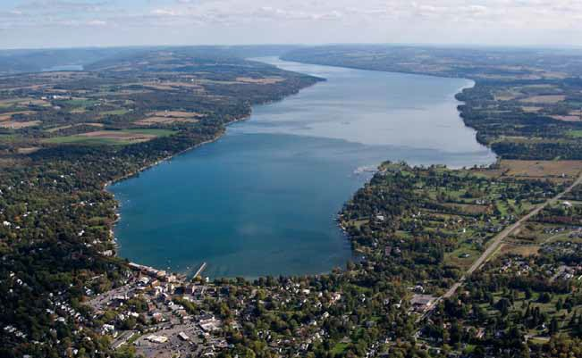

CHAPTER 1: InTRODUCTIOn

Aerial view of Skaneateles Lake. Credit: George Hernandez

In 2015, the Skaneateles Open Space Committee and community leaders established a partnership with the Central New York Regional Planning
and Development Board in order to compile an Open Space Plan. Concerned with the loss of agricultural and open space resources throughout the Town, the Committee’s goal was to develop recommendations to protect natural and cultural resources, to support agricultural sustainability, and to protect Skaneateles Lake.

The Plan was completed in cooperation with public and private partners including elected officials, Town Board members, residents, farmers, and agency representatives. The planning process provided an opportunity to identify unique and
valued natural resources and to present cost effective tools and techniques to protect them. The report recommends land use practices that will avoid urban sprawl and haphazard or arbitrary growth.

Statement of Purpose
The Skaneateles Open Space Plan provides a strategy for the preservation of agricultural land and other unique and valued open space. It is designed to serve as a living document that can be referenced and updated on a regular basis in order to protect the areas that define the community character. The recommendations are presented
in order to promote wise land use decisions regarding the future of Skaneateles.

Benefits of an Open Space Plan
The Open Space Plan provides numerous benefits to the Skaneateles community. Through detailed recommendations developed to safeguard the natural, historic, and cultural heritage of Skaneateles, the Plan encourages healthy communities and outdoor recreation by
protecting scenic views, agricultural lands, forests, unique habitats, wildlife habitats, and critical environmental areas. Open space protection
can also help to mitigate pollution, improve water quality, and reduce stormwater runoff and soil erosion. Priorities are established for lake watershed and water quality protection, trails, and ways to connect open space corridors within Skaneateles with neighboring municipalities.
Many of the recommendation are based on the following Smart Growth principles:

  - Mixed land use, diverse housing, and compact design
  - Attractive community with a strong sense of
place
  - Preservation of farmland, unique viewsheds and critical environmental areas
  - Development directed towards existing communities
  - Development decisions that are predictable, fair, and cost effective
  - Encouragement of community and stakeholder collaboration in development decisions

Legislative Basis for Open Space
The first statewide Open Space Conservation Plan was adopted by the New York State Legislature
in 1992. The State then launched an effort to encourage municipalities to develop their own open space plans in order to ensure grassroots involvement in the long term protection of valued resources for future generations.

A Quality Communities Task Force was established in 2000 by Governor Pataki to define ways in which the state could help local governments
and conservation groups with land development,

The Value of Open Space

Open space refers to land that is not intensively developed for residential, commercial, industrial or institutional use. It can be publicly or privately owned land and includes areas such as wetlands, parks,
agricultural or forested land, and water bodies such as Skaneateles Lake and its shoreline. The Skaneateles Open Space
Plan also recognizes unique cultural and historic resources throughout the Town.
preservation and protection measures that would enhance economic development and
environmental protection. The Task Force findings emphasized the importance of protecting valued land such as forests, agriculture and critical environmental areas. The findings helped
to strengthen the conservation role of local governments, county and regional planning boards through land use controls.

Local governments have the authority to avoid urban sprawl and to control economic growth and development in areas that already have well developed infrastructure such as sewer, water, roads. By taking this approach, communities can protect farmland, forests, and other valuable open space resources. Communities that engage in planned development with a focus on open space conservation are better able to attract businesses and jobs that improve the economy and enhance the local identity and pride.

Local Efforts to Protect Open Space
The Town and Village of Skaneateles updated their Joint Comprehensive Plan in 2015 and it now serves as a tool for directing the municipal planning and development process. The Plan identifies priority goals, objectives, and actions that provide guidance for the future protection of the community and the environment. It focuses on Smart Growth Principles and development that features pedestrian-friendly, walkable neighborhoods and mixed-use development, while protecting large areas of the rural landscape. Recommendations presented in the Plan are based on the continuation of laws, practices, services and actions that are currently in place.

“The Plan recognizes that all communities change as a result of environmental, economic, political and other factors. The purpose of The Plan is to influence and channel such change in order to ensure that the fundamental attributes valued by the community are protected for generations to come.”
Adoption of the Comprehensive Plan came after a review process that lasted nearly two years. The Town Board unanimously adopted the Comprehensive Plan in August 2015 and the Village Board adopted it in September. The Town then initiated plans to conduct a zoning analysis to update its codes in relation to the updated Plan. However, a lawsuit was later filed
in December 2015 in the New York State Supreme Court in Onondaga County by two Skaneateles residents (a former town board member and a business owner) who challenged the adequacy of the State Environmental Quality Review process of the comprehensive plan and its subsequent adoption. The lawsuit was resolved during the late summer 2016 through a process of public meetings with stakeholders.

The Skaneateles Open Space Planning
Process
Numerous documents were reviewed in preparation for the Open Space Plan, including the Town and Village Comprehensive Plan, the Village Climate Action Plan, Town and Village websites, Onondaga County’s 2010 Development Guide, Onondaga County Hazard Mitigation Plan, Strategies for a Sustainable Skaneateles, the Land Preservation Funds Policy, the Citizens to Preserve the Character of Skaneateles website, City of Syracuse Watershed Rules & Regulations, erosion and stormwater regulations, watershed overlay district, lakeshore regulations, water districts map, a watershed map, ‘A Vision for
the Skaneateles Highlands’ (FLLT, 2009) April 2015, the draft Onondaga County Sustainable Development Plan, the zoning district map, and the Zoning Law of the Town of Skaneateles.

Throughout the planning process, viewscapes and valued land were identified, community partnerships were maintained with federal, state and local governments and community groups, funding needs and grant opportunities were summarized, and community education and outreach was organized through a public meeting.

An initial goal for the Open Space Committee was to generate current municipal maps for the Town. In response to this goal, the CNY RPDB developed a comprehensive set of maps displaying the following characteristics using
Geographic Information System (GIS) technology: agricultural soils, primary and principal aquifers, topography, flood zones, community and historic sites, land use, soil erodibility (K-factor), ortho imagery (aerial photography), land parcels, water resources, wetlands, watershed boundaries, public lands, trails, viewsheds, prime agricultural properties, conservation lands, conservation easements, land cover, historic sites, and town land. The detailed mapping provided the foundation for wise and well-informed land use decision-making regarding conservation and open space planning. The maps also provided valuable

TOWN OF SKANEATELES
Town of Camillus Town of Marcellus
Orthoimagery

Town of Skaneateles
D
k

0 0.25 0.5 1 Miles [
AR HILL RD

EF321

Data obtained from the United States Geological Survey, the New York State Department of Transportation, and the Syracuse - Onondaga County Planning Agency. The CNYRPDB does not guarantee the accuracy or completeness of this map. Please see text for full disclaimer. Map created: August 2016.
VISI

EF175
_`20

EF41A

@A41

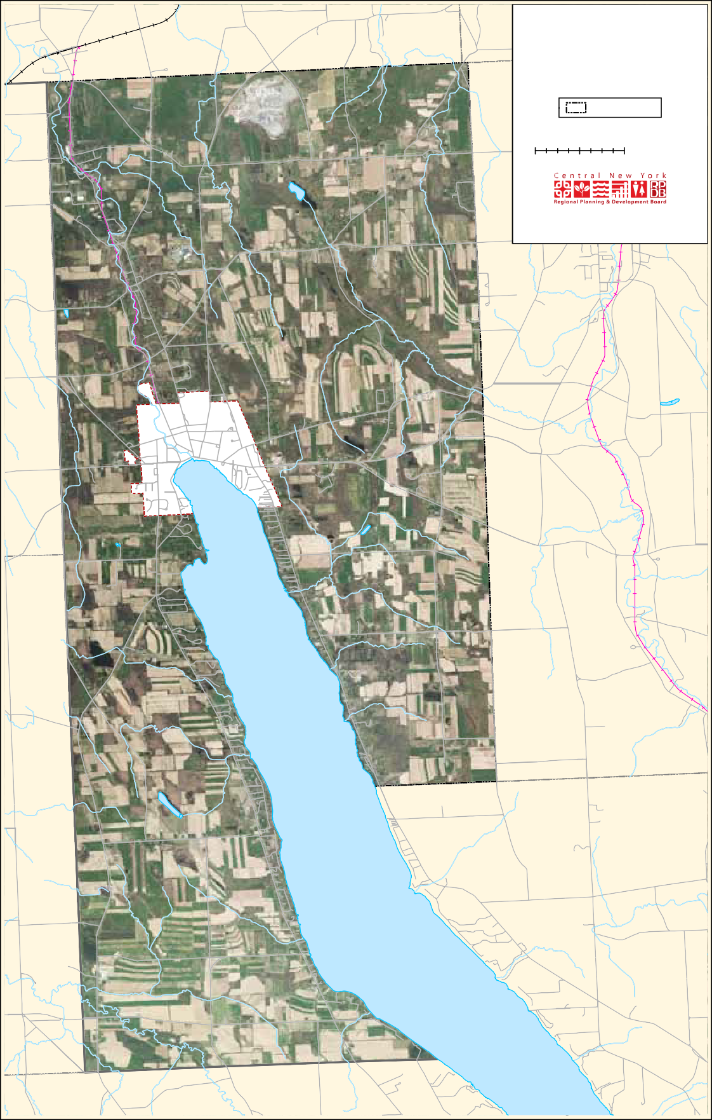
SHORT RD

EF359
BENSON R

EF38A
ETARY RD
ALBRING RD

Skaneateles_T_Orthoimagery

Figure 1: Orthoimagery

components from which decisions were made regarding the protection of natural resources, plans for trail development, and connectivity among parks and open space.

Throughout the planning process, discussions took place on the installation and expansion of
hiking and bicycle paths in the context of the Open Space Plan. The CNY RPDB and the Open Space Committee members consulted with the local Rails to Trails Committee (later known as the Town of Skaneateles Multi-Use Trails Committee) on opportunities for habitat protection, connectivity, and the development of a Greenway Corridor
with tree plantings on public and private land that will help to define and beautify major highways. Tree Advisory Boards and Commissions were identified as effective ways to manage the cost of installations and to maintain vegetation along the greenway corridors.

Committee members also discussed the importance of early detection, education, and environmentally-safe controls for invasive species. These are non-native plants or animals that can cause harm to the environment, the economy and/or to human health. Without the presence
of natural controls, invasives spread rapidly and are extremely difficult to manage. They can cause the loss of natural habitat and native species, and significant economic hardship through impacts on outdoor recreation, trees, agricultural crops, and livestock. Because of the significant threat to biodiversity, communities throughout the country have placed a high priority on early detection
and rapid response to infestations. Once a new invasive is identified, the NYS DEC encourages resource managers to address the important components of an effective response, including coordination, communication, public outreach, planning, science, information management, laws and regulations, resources and logistics.
During the summer of 2015, the Open Space Committee worked with the CNY RPDB to identify and prioritize land parcels for potential inclusion in the Open Space Plan. Committee members initially worked from a list of significant viewsheds that had been compiled for the 2005 Town and Village of Skaneateles Joint Comprehensive Plan. The list served as a starting point for a discussion at the May 2015 Open Space Planning Committee meeting at which time additional views and priority conservation areas were added. The CNY RPDB then added the sites to a map and included the directional views. Several sites were also photographed by committee members Rob and Claire Howard (Appendix E).

The Open Space Committee met in 2015 and 2016. Additional meetings were held with federal, state, regional, and local partners such as the Natural Resource Conservation Service, the Onondaga County Soil and Water Conservation District, the New York Agricultural Land Trust, the Syracuse Onondaga County Planning Agency, Cornell Cooperative Extension, and the Finger Lakes Land Trust.

Planning Partners
Establishing and maintaining local partnerships were critical components to the open space planning process. Committee members collaborated with federal, state and local governments, community groups, not-for-profit organizations and landowners in order to establish and achieve open space conservation goals.
Outreach was made with the following groups:
- Cornell Cooperative Extension of Onondaga County
- Finger Lakes Land Trust
- Local Agriculture & Land Use Leadership Institute (LALULI)
- New York Agricultural Land Trust, Meg Schader

- North Country Trail Association
- Onondaga Agriculture Council
- Town and Village Boards
- Skaneateles Multi-Use Trail Committee
- Skaneateles Conservation Area Advisory Committee
- Skaneateles Lake Association
- Open Space Plan Regional Advisory Committee
- Skaneateles Town Historical Society
- Syracuse Onondaga County Planning Agency
- Onondaga County Soil and Water Conservation District

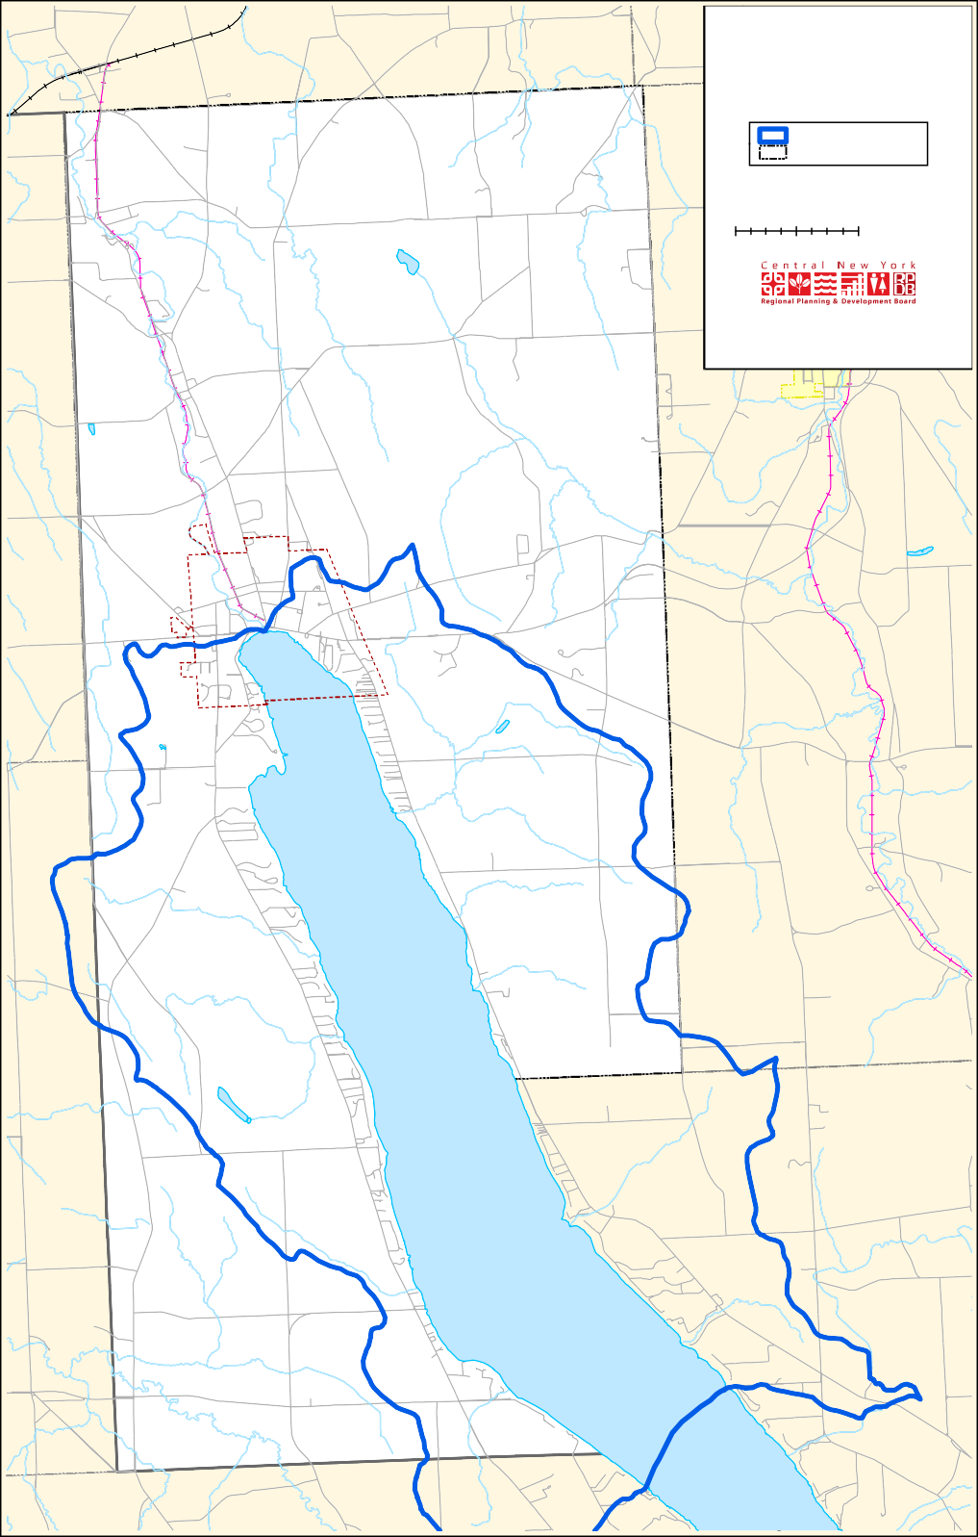
TOWN OF SKANEATELES
Watershed
Skaneateles Lake Watershed Town of Skaneateles
0 0.25 0.5
1 Miles
[
EF
321
Data obtained from the United States Geological Survey, New York State Department of Transportation, and the Syracuse - Onondaga County Planning Agency. This map was created for planning purposes only. The CNYRPDB does not guarantee the accuracy or completeness of this map. Please see text for full disclaimer. Snowmobile trails per data received from Mark Tucker 4/18/2016. Map created: August 2016.
EF175
`_20
EF41A
@A41
F359
F38A
Skaneateles_T_Watershed
VISI
SHORT RD
RUSSELLS
D
k
AR HILL RD

Figure 2: Skaneateles Lake Watershed
ETARY RD
BENSON R
ALBRING RD

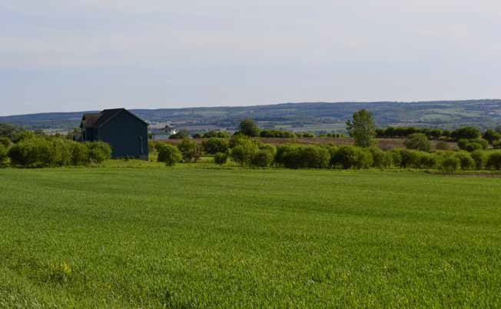
Scenic view, Skaneateles

CHAPTER 2: OPEn SPACE GOALS AnD OBjECTIVES

An initial task of the Open Space Planning Committee was to recognize the characteristics that make Skaneateles unique and also to identify the priority issues of concern. These features influenced the development of open space goals and objectives.

Valued Resources and Characteristics
- Skaneateles Lake and its watershed
- Historic buildings and sites
- Agricultural land, wetlands, forests, and the rural-agrarian landscape
- The small-town character and friendly community
- A healthy lifestyle and environmental protection
- Energy sustainability and reduced greenhouse
gas emissions

Issues of Concern
- Development pressure and the changing scale of property ownership throughout the Town are priorities of concern. The rural character of the Skaneateles landscape is negatively influenced by low density single-use development. Wise land use management is needed to facilitate the capacity for the town to grow and evolve while protecting the current quality of life. The population declined by 8% between 1970 and 2010 but the number of housing lots has increased as agricultural land is replaced by large residential lots.
- Economic pressure is a concern because of high purchase prices and tax rates for lakefront and upland property. This creates heavy financial burdens for the segments of the population such as the farming community, young families, and senior citizens.
- Skaneateles Lake serves as a drinking water

TOWN OF SKANEATELES
Land Use and Agricultural District
D
k
AR HILL RD

EF321
Charlie Major Trail Snowmobile Trails Agricultural District
SkParcels2015_buf_1mi: Land use 3
CatName
Agricultural Commercial Community Services Industrial
Public Services
Recreation and Entertainment Residential
Vacant Land
Wild, Forested, Conservation Lands and Public Parks
Town of Skaneateles
VISI

D

Charlie Major Nature Trail

0 0.25 0.5 1 Miles [

EF175
`_20

Data obtained from the United States Geological Survey, the United States Department of Agriculture, the New York State Department of Transportation, and the Syracuse - Onondaga County Planning Agency. This map was created for planning purposes only. The CNYRPDB does not guarantee the accuracy or completeness of this map. Please see text for full disclaimer. Snowmobile trails per data received from Mark Tucker 4/18/2016. Map created: August 2016.

EF41A

@A41

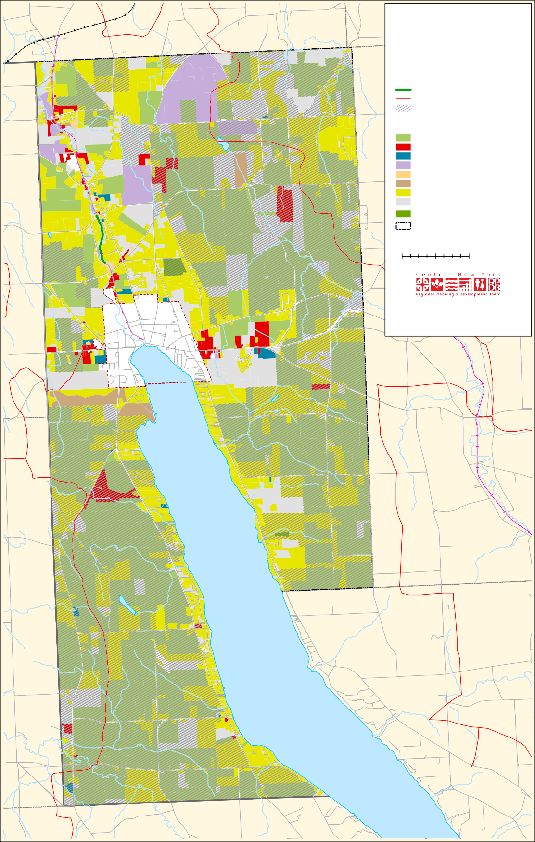
SHORT RD

EF359
BENSON R

EF38A
RUSSELLS
ETARY RD
ALBRING RD

Skaneateles_T_LandUse

Figure 3: Land Use

source for the City of Syracuse, the villages of Skaneateles, Jordan, and Elbridge and all or parts of the Town of Skaneateles and Elbridge. Lake water quality is impacted by nutrient loading from agricultural practices and urban stormwater runoff.
- There is a general uncertainly about the future of farming because of the high demand for residential development.
- There is a lack of connectivity between open space parcels that could provide continuous travel corridors for wildlife and people.
- The community strives to balance issues of individual rights vs. environmental protection.

Guiding Principles
The following principles were developed to guide the content of the Skaneateles Open Space Plan:
- Maintain the Town’s rural character, agricultural sustainability, natural resources, and water quality.
- Provide for recreational and educational opportunities, economic vitality, and a strong sense of local pride and identity.
- Provide options for connecting ecologically significant natural corridors, greenways and scenic routes.
- Make recommendations that are consistent with the Skaneateles Comprehensive Plan.
- Make recommendations that are consistent with the “Strategies for Sustainable Skaneateles” and the goals established by the Skaneateles Lake Association.
- Make recommendations that are based on guidelines defined in the “Leadership in Energy and Environmental Design (LEED) for Neighborhood Development”.
- Support local zoning and subdivision ordinances that facilitate the protection of farmland and valued open space.
- Collaborate with federal, state and local governments, community groups, not-for-profit organizations, landowners, and others that promote research, public awareness of climate change issues, and strategies in support of open space.
- Review the Open Space Plan at least every five years and incorporate updates that reflect current priorities for open space conservation.

Conservation, open space planning, and natural resource protection are top priorities for the Skaneateles community. Committee discussions have focused on open space conservation strategies through conservation land grants, landowner incentives, regulation, fee acquisition, purchase of conservation easements, and support of Smart Growth principles. The recommendations presented below provide opportunities for Skaneateles to protect and maintain valued resources such as Skaneateles Lake and its watershed, agricultural land, parks, historic sites, and unique scenic viewsheds.

Goal 1: Preserve and protect areas with natural and cultural significance
3 Identify and prioritize areas based on ecological, scenic, and agricultural significance. Select sites that will protect valued habitats and that will support biodiversity through healthy and sustainable ecosystems.
3 Apply Smart Growth principles. Improve the effectiveness of the Town’s existing Open
Space Zoning and Subdivision provisions. These provisions allow the Planning Board to require flexible lot sizes and higher density cluster development on portions of tracts of land and conservation easements to preserve most of
a large tract for conservation and agricultural purposes. (See Sections 148-9C and 148-9G of the Town Zoning Law.)
3 Protect exceptional cultural features, historic sites, and unique areas through the use of conservation easements. Consider the use of short-term (five or ten-year) easements with financial support from the Open Space Preservation Fund that would help agricultural property owners pay for land taxes.
3 Protect forests, hedgerows, and other vegetation in parks and along roadways for the purpose of carbon sequestration, air quality

improvement, soil stabilization, wildlife, and outdoor recreation. Apply forestry management strategies to promote healthy growth, taking care that viewsheds are not impacted.
3 Identify and prioritize wetlands for protection based on size and functionality.
3 Collaborate with land trusts such as the Finger Lakes Land Trust and the Central New York Land Trust to purchase and sustain lands in permanent conservation. Research options to establish a local land trust.
3 Identify sites with unique features or ecological significance that may qualify as Critical Environmental Areas. Strengthen town codes to protect these areas.
3 Promote conservation practices to maintain hunting areas and fishing habitats.
3 Develop land use regulatory protections to prevent haphazard and sprawling low-density development, and to prohibit construction on steep hillsides and stream buffers.
3 Develop and maintain a greenway corridor and create landscaped routes to define and beautify major entryways to Skaneateles.
3 Reclaim spent mines as green space.
- Restrict mining operations to the current Mining Overlay District and discourage expansion of land uses adjacent to active mining areas that are incompatible with mining operations.
- Compress the current mining overlay district to exclude established residential areas, wetlands, water courses, and high value agricultural areas.
- Consider a ‘No New Mines’ ordinance.

Goal 2: Protect water resources
3 Reduce soil erosion and nutrient loading to Skaneateles Lake, Skaneateles Creek, lake
tributaries, and wetlands through wise land use practices and implementation of agricultural Best Management Practices (BMPs).
3 Encourage the farming community to work with the Soil and Water Conservation District (SWCD) on whole farm plans and BMP installations.
3 Support the SWCD on shoreline stabilization projects along Skaneateles Lake and Skaneateles Creek.
3 Strengthen criteria and thresholds relating to construction, impermeable surface coverage, land disturbance and environmental reviews for new development.
3 Install green infrastructure to reduce the quality and quantity of stormwater runoff, and to facilitate flood control through soil infiltration and groundwater recharge.
3 Improve the capacity of stormwater collection systems such as rain gardens, porous pavement, rain barrels, and French storm drains. Reduce stormwater runoff by encouraging downspout disconnection, bioinfiltration, and rainwater harvesting for residential and business communities.
3 Install vegetative plantings along riparian waterways and encourage proper septic tank maintenance.
3 Support the Village’s Rain Catchers Program to reduce flooding and stormwater runoff.

Goal 3: Develop a sustainable, long- term mechanism to finance open space preservation
3 Work with state representatives to enact the Community Preservation Act (CPA) that would allow Skaneateles to enact a real estate transfer fee of up to 2% on the sale price of residential property. Use this funding for local open space initiatives and for the creation of parks and trails. Pass a public referendum endorsing local implementation of the CPA.
3 Create a financing mechanism that supports rehabilitation of degraded lands when active mining ceases.

3 Publicize the availability and intended use of the Skaneateles Open Space Fund. Encourage donations from the public in the form of money and land.
3 Identify and develop a strategy to finance and maintain recreational trails.
3 Apply for county, regional and statewide grants to fund open space preservation efforts such as the NYS Department of Agriculture and Markets Farmland Protection Implementation Grants
and the USDA Farm and Ranch Lands Protection Program. Pursue Onondaga County Agriculture Council funding options through the New York Agriculture Land Trust.
3 Encourage New York State to provide additional funding for the New York State’s Farmland Protection Implementation Grant Program in order to protect prime agricultural areas and to ensure that they remain in agriculture.
3 Consider bonding to fund local open space initiatives.
3 Encourage the City of Syracuse, the State of New York, the federal government, and the
private sector to resume a program to secure land in the Skaneateles Lake watershed through the acquisition of conservation easements. This will help to ensure the future of Syracuse’s drinking water supply.

Goal 4: Protect valuable farmland and the rural agrarian landscape
3 Promote the purchase and/or transfer of development rights and other preservation tools to redirect development away from valued agricultural and open space areas and towards priority areas for new investment.
3 Encourage and enable agriculturally-related businesses (roadside farm markets and vineyard
tasting rooms) and other forms of agritourism.
3 Support the expansion of agriculture districts.
3 Develop agricultural protection zoning in priority areas to stabilize the agricultural land base, discourage land uses other than agriculture, and limit the density of residential development within these districts.
3 Establish and maintain a dialogue with the farm community to address mutual concerns over which farmers and local government have some control.
3 Work with Onondaga County to update the comprehensive farmland protection plan that provides a combination of regulatory incentives and relief, compensation to landowners such as tax rebates or leasing of development rights, and a funding mechanism to finance the preservation of farmland.
3 Improve existing design standards for built pattern and form that ensure the compatibility of new development with the Town’s historic rural- agrarian vernacular.
3 Support continued funding of the Onondaga County Agriculture Council.

Goal 5: Develop and maintain a network of pedestrian and recreational trails
3 Identify opportunities for and develop an interconnecting network of trails and bikeways that incorporate natural features such as the Skaneateles Creek corridor, segments of the lake shore, and stream corridors.
3 Consider expansion of the existing trail system along Skaneateles Creek to create a continuous path to connect the Steve Krause Trail creekwalk in the village, the Charlie Major Nature Trail in Mottville, and the former Welch Allyn employee exercise trail. Evaluate intermunicipal options that

would extend the trail beyond the town borders to the Erie Canalway Trail in Elbridge.
3 Extend or connect to the Charlie Major Trail by filing an agreement that grants an easement to the Town for recreational use of city-owned property located on Skaneateles Creek, just north of Old Seneca Turnpike, where three water
conduits prevent personal ownership and building construction.
3 Explore options for developing a hiking trail along the western highlands from Mandana to the Village of Skaneateles.
3 Identify and evaluate the use of town-owned land (such as the property behind Grace Chapel) for new and expanded trails and parks and other conservation purposes.
3 Explore options to develop a recreation trail with scenic views along the eastern highlands and potential routes to extend a path to connect
Borodino with Shepard Settlement.
3 Finalize negotiations with local property owners to donate land to the town on the south side of Old Seneca Turnpike and develop plans to install and maintain a trail through this area.

Goal 6: Provide educational opportunities for diverse target groups

3 Work with organizations in Onondaga County such as Cooperative Extension and Soil and Water Conservation District to sponsor educational forums and tours that present the benefits
of agricultural sustainability, maintenance of community character and viewscapes, and lake water quality protection. Present to diverse target groups such as newly elected municipal officials, the farming community, and real estate agents.

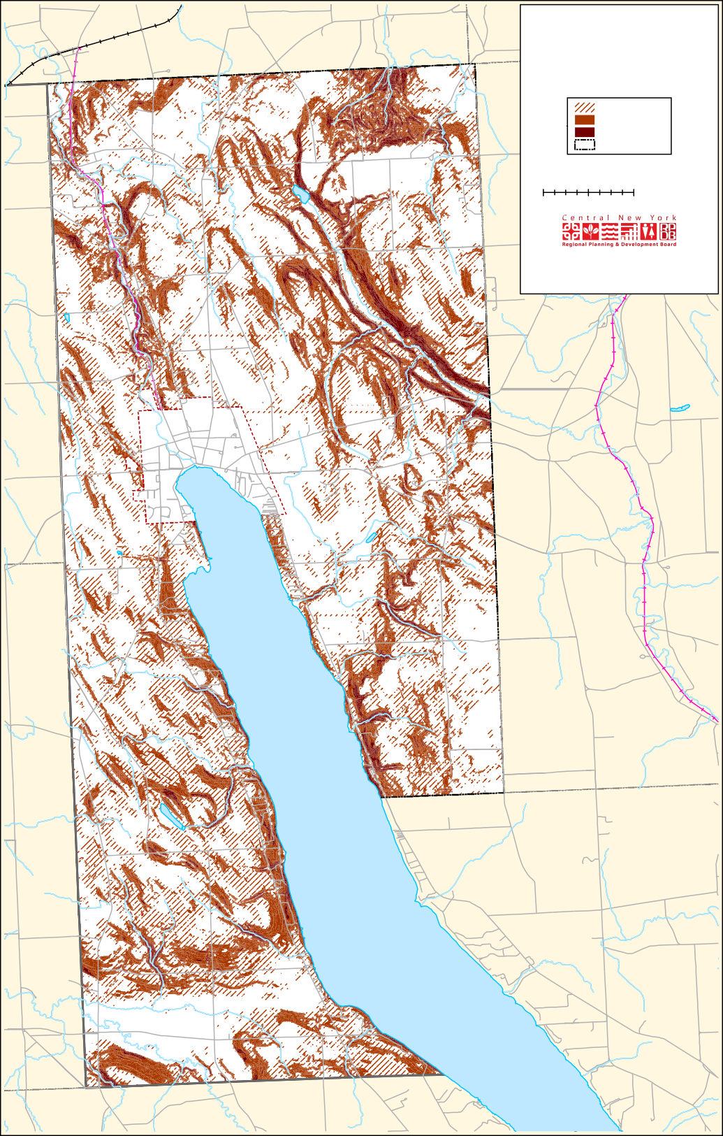
TOWN OF SKANEATELES
Slope
4% - 7%
8% - 15%
16% - 50%
Town of Skaneateles
0 0.25 0.5
1 Miles
[
EF321
Data obtained from the United States Geological Survey, the New York State Department of Transportation, and the Syracuse - Onondaga County Planning Agency. The CNYRPDB does not guarantee the accuracy or completeness of this map. Please see text for full disclaimer. Snowmobile trails per data received from Mark Tucker 4/18/2016. Map created: August 2016.
EF175
`_20
EF41A
@A41
EF359
F38A
Skaneateles_T_Slope
VISI
SHORT RD
RUSSELLS
D
k
AR HILL RD

Figure 4: Slope
ETARY RD
BENSON R
ALBRING RD

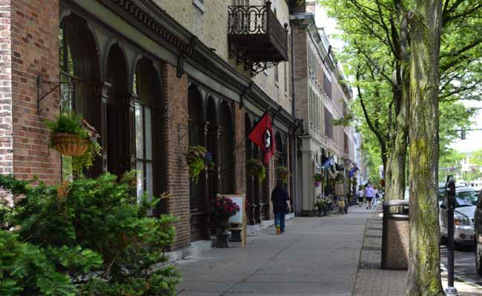

East Genesee Street shops, Village of Skaneateles

CHAPTER 3: CULTURAL AnD EnVIROnmEnTAL InFLUEnCES

The Town of Skaneateles is located at the northern end of Skaneateles Lake. 27% of the Skaneateles Lake watershed, 45% of the water surface, and 40% of the shoreline lie within the Town boundary. Skaneateles Creek originates from Skaneateles Lake and flows north to the Seneca River. The lake and creek are part of the Oswego River Basin.

The Town has significant cultural, historic, natural, and recreational resources and exhibits diversity in terms of industry size, products and services provided and labor force skill requirements. Retail stores are located primarily within the Village center and a limited amount of service and
automobile-oriented development is located along Route 20 to the east and west of the Village.

Skaneateles Lake, lovely historic homes, and
attractive retail storefronts have created a desirable tourist destination but automobile and truck traffic is an issue of concern especially during the summer months. Numerous outdoor
recreation opportunities are available throughout the town and at the Skaneateles Community Center. The 292-acre Skaneateles Recreation Area provides outdoor recreation space for Town and Village residents. A public dock is located at the lake but public boat launching and mooring facilities are limited.

History
Skaneateles was established in 1830 and the Village was incorporated is 1833 during a time when agriculture was centered on dairy operations and field crops. By 1850, industry in the Village

and its surrounding hamlets was producing wool cloth, mill machinery, carriages, sleighs, paper, bricks, iron work, and farm implements. Teasel, a natural burr used to raise the nap on woven wool, was cultivated until the middle of the twentieth century. Canoes, motorboats and sailboats (including the Lightning and the Comet) were built in Skaneateles from 1876 to 1945. A downtown Historic District was established in 1985. The population has remained relatively stable during the past two decades. Residential and commercial development is limited by public water and sewer facilities. Residential properties in the Town are dependent on wells and septic systems.

Local Government
The Village of Skaneateles is governed by a five-member Board of Trustees. The Town is
governed by a five-member Town Council. Local regulatory tools include building codes, zoning and subdivision ordinances, a NFIP flood damage flood prevention ordinance, and site plan review requirements. The Town has a Planning Board and Zoning Board of Appeals. There are six zoning
districts: rural farming and forest, rural residential, highway commercial, hamlet, industrial/research/ office, and village. New York’s Agricultural District Law (Article 25-AA PDF of the NYS Agriculture and Markets Law) was enacted in 1971 in order to help keep farmland in agricultural production. Districts help to protect agriculture by discouraging the conversion of farmland to non-agricultural land uses.

Zoning is a way in which local governments can protect natural resources and land use activities. This is done by separating an area into districts and then establishing laws that govern the use of land.
Zoning is used to regulate the location and use of structures on land in the Town of Skaneateles, outside of the incorporated Village. The Town is
divided into land use districts. There are limitations on the allowable use, building size and lot coverage, setbacks from property lines, parking, and signage for each district. Zoning variances
can be developed to protect unusual landscape features such as steep hillsides, scenic vistas, and drainage patterns that may impact development. Subdivision refers to the division of any parcel of land into two or more lots, plots, or sites for the purpose of sale, lease or building development. The minimum lot size required for a conventional subdivision is two acres. The lot to be subdivided must have a minimum of four acres of land.
Wetlands, road rights-of-way, utility easements and one-hundred-year floodplains are excluded from subdivision calculations. Most of the zoning in the Town limits development to a two-acre lot density.

Committees
Skaneateles maintains an Alternative Energy Committee and a Tree Advisory Board. Municipal officials are planning to install a solar car charging station in the Village and permeable pavement
is being installed to reduce stormwater runoff. Village Trustees recently approved the purchase of LED streetlights and are working to improve streets to provide greater pedestrian safety and
convenience. An Open Space Committee is charged with identifying appropriate land, locating funding opportunities, and ways to implement the Town’s goals to preserve open space. The Skaneateles Architectural and Visual Identification Team was created to identify and catalog items of significant historical, natural, and cultural prominence within the Town and Village of Skaneateles.

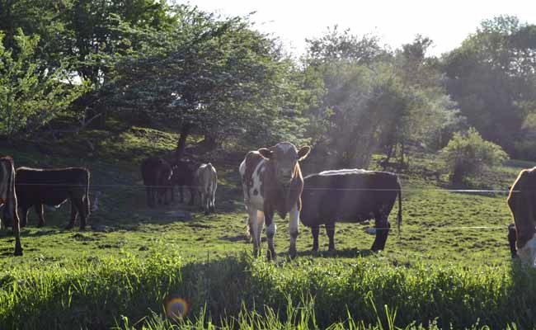

Cows in pasture, Skaneateles

CHAPTER 4: AREAS TO PROTECT In SkAnEATELES

The Town of Skaneateles has unique open space characteristics that define it as a desirable place to live and work. This chapter defines the features that need to be protected.

Agriculture
Agriculture is an important component of the economy, providing food for local consumption and export, jobs, open space with scenic vistas, and wildlife habitat. The farming industry, encompassing 12,205 acres and 40% of the overall land use, has experienced development pressures and high land prices, similar to many other areas of New York State. The preservation of farmland and agricultural industries is a primary goal for
the community to ensure that farms with highly productive soils are preserved while marginal land is reserved for business and residential
development. Many of the soils in the Skaneateles
Lake watershed exhibit poor permeability and erosion vulnerability which makes land use regulations that control development a priority for local planners. The Town maintains an Agricultural District Program and the Skaneateles Lake Watershed Agricultural Program which are designed to reduce agricultural pollution loading to the lake and tributaries without negatively impacting the farm economies.

Soils
Two categories of farmland were mapped as part of the Skaneateles Open Space site prioritization process. The first category, according to the United States Department of Agriculture, ‘Prime and Important Farmland’, is defined as prime, unique, and farmlands of statewide or local importance. Prime farmland is land that has
the best combination of physical and chemical

TOWN OF SKANEATELES
Town of Camillus Town of Marcellus
Agricultural Soils
Prime Farmland
Farmland of statewide importance Prime Farmland if Drained
Not Prime Farmland Town of Skaneateles
D
k
AR HILL RD

EF321
VISI
0 0.25 0.5 1 Miles [

Data obtained from the United States Geological Survey, the United States Department of Agriculture, the New York State Department of Transportation, and the Syracuse - Onondaga County Planning Agency. This map was created for planning purposes only. The CNYRPDB does not guarantee the accuracy or completeness of this map. Please see text for full disclaimer. Map created: August 2016.

EF175
`_20

EF41A

@A41

SHORT RD

EF359
BENSON R

EF38A
ETARY RD
ALBRING RD

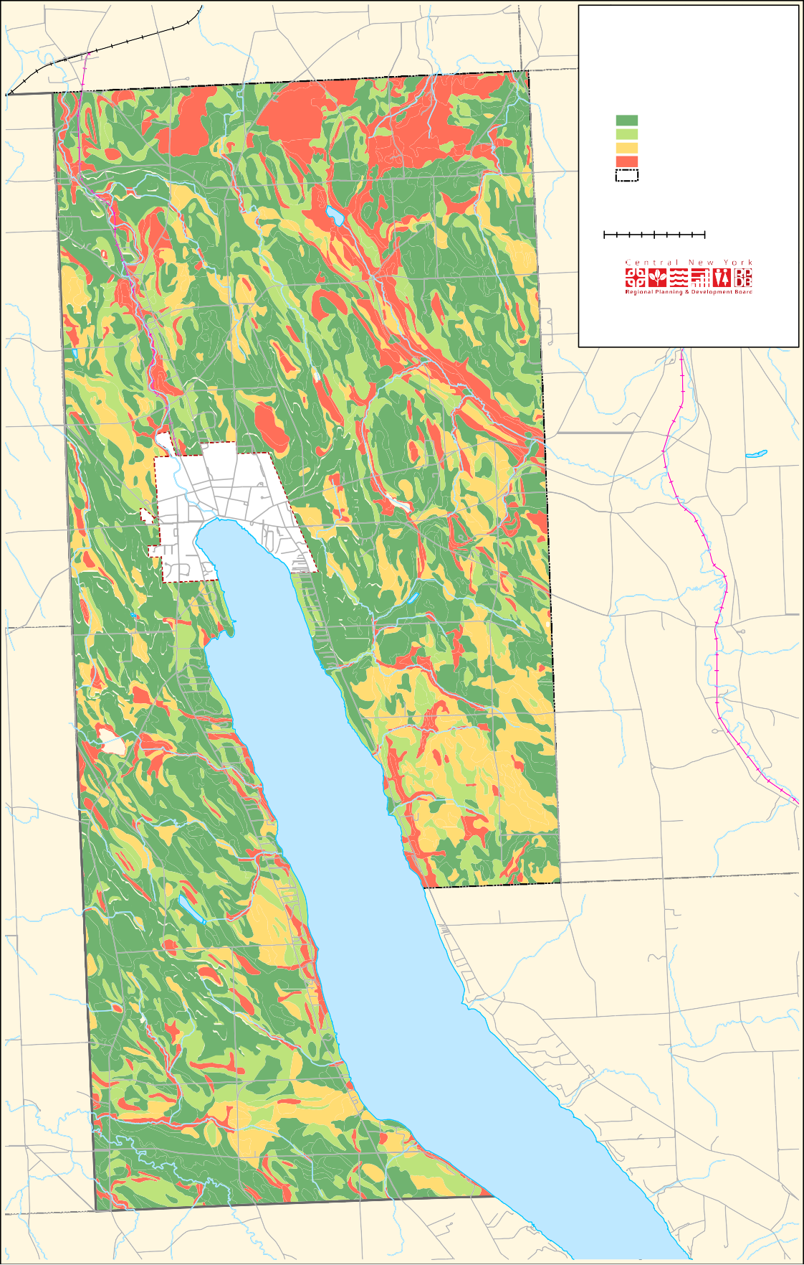
Skaneateles_T_AgSoils

Figure 5: Agricultural Soils

characteristics for producing food, feed, forage, fiber, and oilseed crops. It is available as cropland, pastureland, rangeland, forest land, or other land, but not urban built-up land or water. The soils are of the highest quality and can economically produce sustained high yields of crops when treated and managed according to acceptable farming methods. Specific technical criteria were
established by Congress to identify prime farmland soils. In general, the criteria reflects adequate natural moisture content; specific soil temperature range; pH between 4.5 and 8.4 in the rooting zone; low susceptibility to flooding; low risk to wind and water erosion; minimum permeability rates; and low rock fragment content.

‘Farmland of Statewide Importance’ is land, in addition to ‘Prime and Important Farmland’, that is of statewide importance for the production
of food, feed, fiber, forage, and oil seed crops. Criteria for defining and delineating this land in Skaneateles are determined by the Soil and Water Conservation District. Farmlands of Statewide Importance include those that are nearly prime farmland and that economically produce high yields of crops when treated and managed according to acceptable farming methods. Some may produce as high a yield as prime farmlands if conditions are favorable. In some states, additional farmlands of statewide importance may include tracts of land that have been designated for agriculture by state law.

Mining
Skaneateles has natural deposits of mineral resources such as limestone, sand, and gravel that are used for construction of roads and buildings. Hansen Aggregates owns a limestone and dolostone mine in Skaneateles covering 270 acres. An application by D.E.M., L.L.C. was made to mine sand and gravel on 18.2 acres of a 74-acre site on Stump Road owned by Darryl and Agnes Meiers.

Skaneateles Lake and its Watershed
Skaneateles Lake, the fifth largest lake in the Finger Lakes region, is the water source for approximately 250,000 people in the Village and Town of Skaneateles, the City of Syracuse, and portions
of Onondaga County. An average daily flow of 42 million gallons of water is drawn from Skaneateles Lake each day and the water is then filtered by coarse screens.

The lake covers 8,960 acres and is 16 miles long.¹ The NYS Department of Environmental Conservation maintains a launch site that is located approximately two miles south of the Village on the west shore. Parking is available for up to 35 cars and trailers. Another public access site is Skaneateles Park, located in the Village.

Land features in Skaneateles and throughout the Finger Lakes region were originally defined by receding glaciers during the last two ice ages. They created the unique topography which is characterized by gorges, rolling hills, beautiful views and fertile agricultural land. Skaneateles Lake is situated in a north-south trending trough with deep valleys and steep sides.

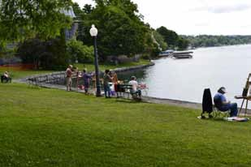
Artists painting on northern shoreline of Skaneateles Lake

The term ‘watershed’ refers to all the land that drains into a given body of water. The Skaneateles Lake watershed covers portions of Onondaga, Cortland, and Cayuga counties and includes residential, forested, and agricultural land. There is a direct correlation between land use activities in the watershed and water quality in Skaneateles Lake.

- NYSDEC website http://www.dec.ny.gov/outdoor/36556.html

Water Quality Standards
Water Quality Standards serve as the basis for programs to protect surface and groundwater in New York State. The standards define the
maximum allowable levels of chemical pollutants and are used as the regulatory targets for permitting, compliance, enforcement, and monitoring and assessing water quality. Waters are classified for their best uses (fishing, source of drinking water, etc.) and the standards (and guidance values) are designed to protect those uses.

The standards and guidance values for Skaneateles Lake have been established by the New York
State Department of Health. All waters in New York State are assigned a letter classification that denotes their best uses. Skaneateles lake water has a high designation of Class AA.
Based on the good water quality in the lake, the NYS Department of Health granted a waiver to the City of Syracuse and the Village of Skaneateles which allows them to utilize the lake as a drinking water supply without a requirement for filtration.
The only necessary water treatment is chlorination and fluoridation.

Syracuse purchased conservation easements on 858 acres of land in the Skaneateles Lake watershed in order to protect the lake water quality and to avoid the costly filtration
requirements. Skaneateles is one of the few large system surface water supplies in the country that is approved as an unfiltered water supply.

Water Quality Protection
Open space conservation and land use regulations are the least expensive option for protection of water quality in Skaneateles Lake but several additional options are also available such as creation of a Lake Watershed Overlay District, floodplain and stormwater management planning requirements, lakeshore regulations, watershed rules and regulations to control erosion and sediment pollution, and steep slope regulations.

Skaneateles Lake Watershed Rules and
Regulations
The Skaneateles Lake Watershed Rules and Regulations are were developed to protect lake water quality. They include land use requirements for homeowners, builders and contractors
that may be planning a project anticipated to disturb 5,000 square feet or more of land in the watershed. For these projects, the permit applicant may need to submit an Erosion and Stormwater Control Plan to the Syracuse Water Department. New York State stormwater
regulations are also in place for projects that will disturb more than one acre of land.

Skaneateles Lake Watershed Land Protection
Program
The Skaneateles Lake Watershed Land Protection Program also focuses on water quality preservation. Onondaga County created the Water Quality Management Agency in 1985 to facilitate communication, public education, and the implementation of watershed protection and management actions.

Skaneateles Lake water quality is also protected through the use of public sewers that are available to Village residents with limited extensions into adjacent Town land (Figure 5). The wastewater treatment plant was constructed by the Village in 1982.

Groundwater
Primary and principal aquifers are located in Skaneateles (Figure 4). The most productive aquifers in New York State are known as primary aquifers and are generally located in unconsolidated sediments (sand and/or gravel deposits). These are defined in the Division of
Water Technical & Operational Guidance Series as “highly productive aquifers presently utilized as sources of water supply by major municipal water supply systems”.

The remaining unconsolidated aquifers in New York State are generally capable of providing 10 to 100 or more gallons per minute. These are called principal aquifers and for the most part are not as

TOWN OF SKANEATELES
Aquifers, Wetlands, and Flood Zones
D
k
AR HILL RD
FEMA 100-year Flood Zones FEMA 500-year Flood Zones State Wetlands
Federal Wetlands Other Wetlands Primary Aquifers Principal Aquifers Town of Skaneateles

EF321
VISI
0 0.25 0.5 1 Miles [

Data obtained from the Federal Emergency Management Agency, the United States Geological Survey, the New York State Department of Transportation, and the Syracuse - Onondaga County Planning Agency. This map was created for planning purposes only. The CNYRPDB does not guarantee the accuracy or completeness of this map. Please see text for full disclaimer. Map created: August 2016.

EF175
_`20

EF41A

@A41

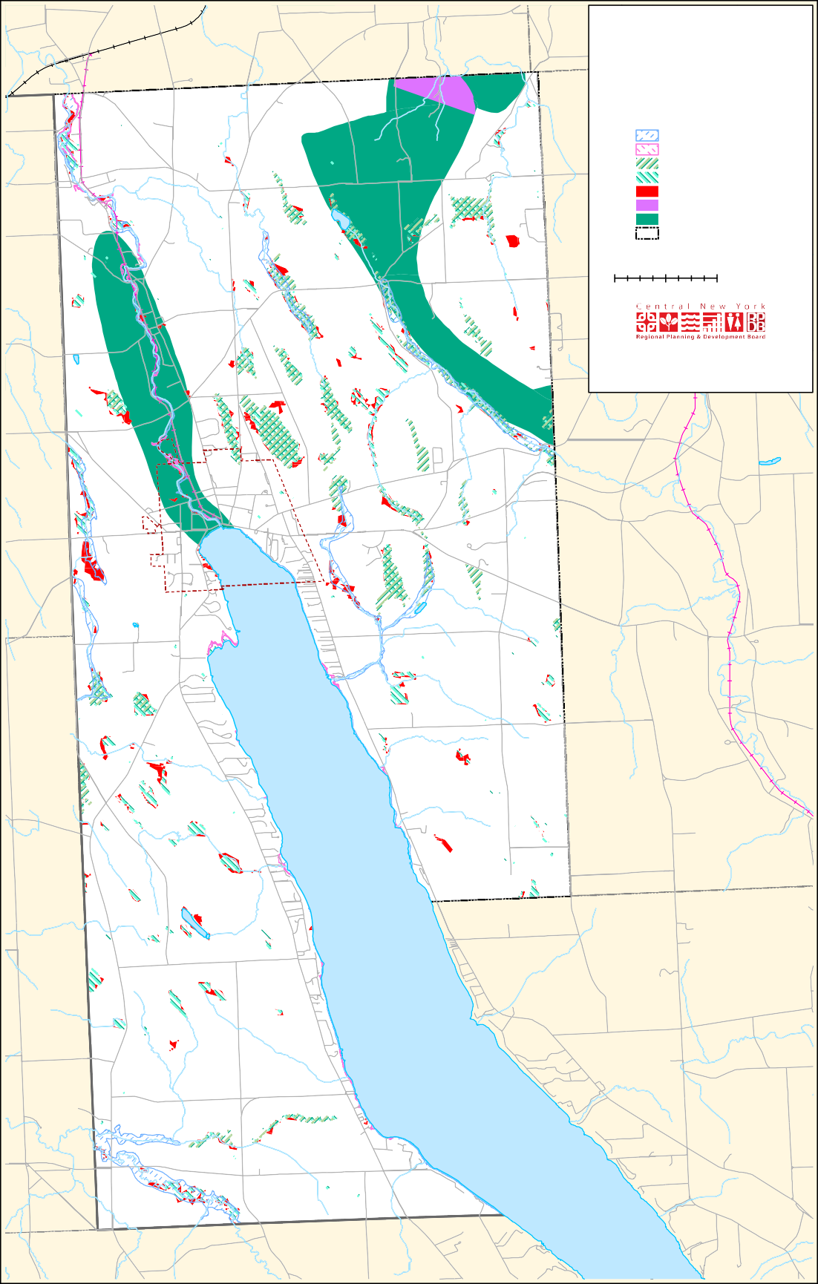
SHORT RD

F359
BENSON R

F38A
ETARY RD
ALBRING RD

Skaneateles_T_AquiferWLandFlood

Figure 6: Aquifers, Wetlands, and Flood Zones

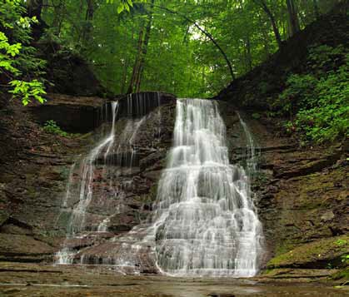and educational initiatives, most notably with two invasive insects that are impacting the Town’s forest resources. In 2014, an invasive insect known as Hemlock woolly adelgid (HWA) was detected along the southern shoreline of Skaneateles Lake.
CCE planted 100 hemlock trees in the spring of 2015 in order to
establish populations of biological controls that might limit the spread of HWA. CCE is partnering with
the Soil and Water Conservation District, Cornell University, and the City of Syracuse Water Department to expand the biological control program along the western shoreline in 2016.

Guppy Falls, Skaneateles Conservation Area. Credit: http://falzguy.com/guppy-falls.html

heavily utilized as primary aquifers. Although other
Emerald Ash Borer (EAB)
Another invasive insect threatening Skaneateles is the Emerald Ash

areas in upstate New York are capable of supplying
groundwater, these delineated areas are the most reliable sources. These aquifers are “known to
be highly productive or whose geology suggests abundant potential water supply, but which are not intensively used as sources of water supply by major municipal systems at the present time” (NYSDEC).

forests
There are 57 acres of forested land in Skaneateles, most of which is privately owned. Trees serve
a valuable function in urban environments by stabilizing soil particles and reducing the rate of erosion. Trees reduce the amount of stormwater runoff, buffer sounds, provide cooling in the summer, and wind protection in the winter.
Forested areas provide timber harvesting jobs and support opportunities for tourism and recreation such as hiking and camping.

Hemlock Woolly Adelgid
Borer (EAB) which was first identified in Central New York in 2013. Large populations of the small fluorescent insect are killing ash trees and are creating significant impacts for local forest composition, ecosystems, and economies. To provide opportunities for future growth of ash trees, CCE is conducting workshops to teach the
public how to collect and preserve ash seeds. CCE is collaborating with the MidAtlantic Regional Seed Bank and with federal organizations to sponsor the educational workshops in the Skaneateles area.

Conservation Areas
Conservation Areas are environmentally distinctive land features that may include features such
as woodland, wetlands, steep slopes, streams, drainage ways, waterfalls, and aquatic sites such as spawning or nursery grounds for fish and wildlife. The Town of Skaneateles owns three conservation areas with nearly 557 acres that are maintained for the benefit of protection and recreation.² An
excellent resource for information, photographs

Cornell Cooperative Extension (CCE) of Onondaga

County remains actively engaged in research
- The Skaneateles Conservation Areas News and Notes newsletter, http://skaak.org/the-areas/

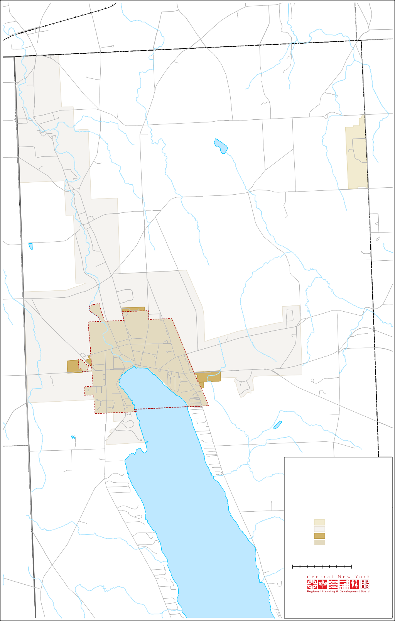
VISIONS
EF321
EF175
`_20
EF41A
TOWN OF SKANEATELES
Sewer and Water Districts
@A41
0 0.2 0.4
0.8 Miles
[
N
Data obtained from the United States Geological Survey, the New York State Department of Transportation, the Syracuse - Onondaga County Planning Agency, and the Town of Skaneateles. This map was created for planning purposes only. The CNYRPDB does not guarantee the accuracy or completeness of this map. Please see text for full disclaimer. Map created: August 2016.
Skaneateles_T_SewerAndWater
Water District, OCWA Water District
Sewer District, Town Sewer District, Village
E ELIZABETH ST
A
N
s
e
CAYUGA COUNTY ONONDAGA COUNTY
BRYANT DR
AR HILL RD
RICKAR

Figure 7: Sewer and Water Districts
COON HILL RD

S H A M
R O C K
R D

SHORT RD

Ni
nemile
Cr
ee
k

Town of Marcellus Town of Spafford
C e
ANT DR
AR HILL RD
e
TER RD

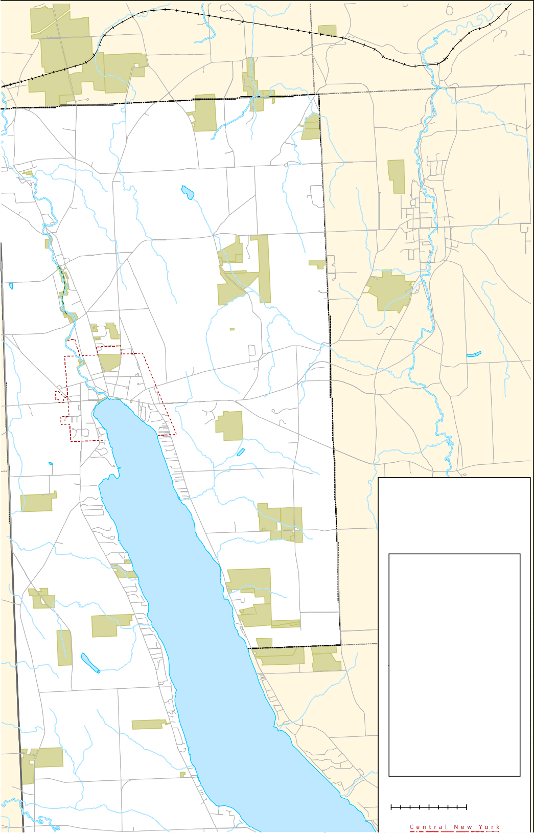Figure 8: Protected Lands
!(8
!(8
!(2
!(8
!(6
!(7
!(11
!(4
!(15
EF321
!(5
D
Charlie Major Nature Trail
!(10
!(15
!(15
!(
12
!(7
!(3
!(15
(15
!(16 !(1 EF175
!(3
!(9 !(14
!(
`_
20
15
!(7
!(7
TOWN OF SKANEATELES
Protected Lands
!(7
!(13
(7
!(7
!(12
1: Austin Park
2: Carpenter's Brook Fish Hatchery 3: City of Syracuse Water
4: Marcellus Central School
!(
7
!(7 !(7
!(7
5: Mottville Fire Co
6: Onondaga County
!(7
@A41
!(7
(!
7
!(7
!(7
!(15
EF359
EF41A
7: Private ownership - Easement
8: Private ownership - Purchase of Development Rights
9: Shotwell Park
10: Skaneateles Conservation Area 11: Skaneateles Falls Park
12: Save the County, Inc. 13: State Boat Launch 14: Thayer Park
15: Town of Skaneateles
16: Village of Skaneateles unnamed park
(
15
0 0.275 0.55
1.1 Miles
[
EF38A
This map consists of publically-owned parks, recreational lands, and lands that haven’t been developed, and privately-owned lands with conservation easements and Purchase of Development Rights (PDR). Also included are protected parcels within one mile of the town border.
VISI
N
L
SHORT RD
RUSSELL
D

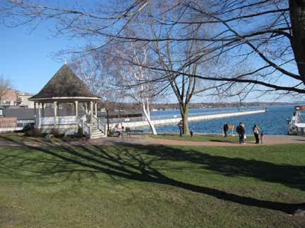Parks
Skaneateles maintains several beautiful parks including Clift Park and Shotwell Memorial Park which has monuments to Skaneateles residents that
served in the Spanish-American War, World War I and II and the Viet Nam and Korean Conflicts. Additional parks include Thayer Park, and Austin Park which has playground equipment, picnic tables, basketball and tennis courts, baseball fields, and a track for walking, biking or blading.

Shotwell Memorial Park. Credit: Meg Brooks, RE/MAX MASTERS

and maps is the Skaneateles Conservation Areas website at https://skaak.org

The Federal Farm and Gully Road areas, located at Old Seneca Turnpike and Gully Road, in the northeast part of the Town. On the nearly 345 acres of land, visitors will find woodland, a fishing pond, a beaver pond, wetlands, a waterfall, observation decks, pavilion, picnic tables, and a lean-to for camping (by permission only). A carry- in-carry-out trash policy is in place and there are no rest room facilities. A children’s fishing derby is held there each year.

The mabel m. Reynolds nature Preserve is located on both sides of Benson Road, at Reynolds Road, in the southwest part of the town. The property was given to the town by the estate of Mabel Reynolds who asked that the family property be open to
the public and used as a nature preserve. The site contains approximately 123 acres of woodland.

The Dunning tract, located on the south side of US Rt. 20 at the intersection with NY Rt. 175, contains approximately 89 acres of woodland and wetland. The remainder is leased for agricultural purposes. Access to the site is through the Grace Chapel parking lot.

Historic Sites
The value of a community is enhanced and shaped by its history. An effort was made in October 2015 to document the historic sites throughout the town that helped to shape the personality and characteristics of Skaneateles. Elizabeth Batlle, Skaneateles Town Historian, identified notable historic sites, cemeteries and homes and compiled brief descriptions of each location (Appendix D). The CNY RPDB included historic sites as a category in the Suitability Criteria Rating system.

Floodplains
The greatest potential for flooding in Skaneateles typically occurs in the early spring during periods of heavy precipitation, warming temperatures, and rapid snowmelt. FEMA flood zones and
wetlands are located on the eastern lake shoreline, along Skaneateles Creek, and in a localized area along the northern border of the Village. In
the Onondaga County Hazard Mitigation Plan the hazard ranking for flooding is listed as low. Flooding in Skaneateles is minimal because the City of Syracuse Water Department regulates water levels at the lake outlet.

Classification | Acres, Town of Skaneateles
Class I Acres | 3.1
Class II Acres | 0
Class III Acres | 55,755.5
Class IV Acres | 97.6
Total Acres | 33.5
Table 1: Classification of Soils in the Town of Skaneateles

Wetlands
NYSDEC regulated wetlands in Skaneateles are displayed in Figure 4. Wetlands are mapped using a variety of information sources such as aerial photography, soil surveys, elevation data, wetlands inventories, and field verification. This information applies to wetlands regulated under the freshwater wetlands act, whether regulated by the department or by towns, cities, villages, or counties.

The DEC is responsible for mapping and classifying wetlands. The classification system establishes four separate classes that rank wetlands according to their ability to perform wetland functions
and provide benefits (Table 1). Class I wetlands have the highest rank, and the ranking descends through Classes II, III and IV. The degree to which wetlands supply benefits depends upon many factors, such as vegetative cover, ecological associations, special features, hydrological and pollution control features, and the wetland distribution and location.

Wetlands resources are valued for their flood and stormwater control, surface and groundwater protection, erosion control, pollution treatment and nutrient cycling, fish and wildlife habitat,
and recreational benefits. Wetlands store and slowly release floodwaters from precipitation

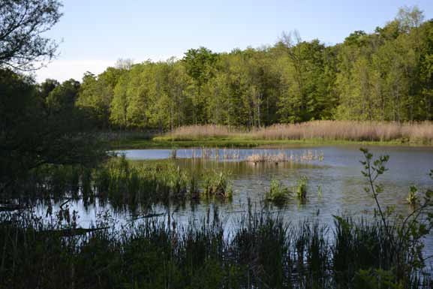
Wetlands, Skaneateles
Town of Skaneateles Open Space Plan October 19, 2016
33

runoff and snowmelt and provide groundwater recharge. Current threats to wetland resources in Skaneateles and throughout Central New York include land development and other land uses,
de-watering or rerouting of contributing land area inflows, pollutant loadings from stormwater runoff and wastewater discharges, and development practices.

It is possible to provide tax incentives by reduced assessments based upon the existence of protected wetlands on a property. The Freshwater Wetlands Act, Article 24 of the Environmental Conservation Law protects and conserves freshwater wetlands that are 12.4 acres or larger. Smaller wetlands connected to larger watershed systems are protected by the federal government. Additional information about Skaneateles wetlands is available in Appendix C.

Trail Resources
Skaneateles is blessed with a variety of cultural, educational, and recreational opportunities.
Continued land use planning is needed to preserve and perpetuate these resources for the enjoyment of future generations. Preservation of natural resources and open space remains a primary objective of local planning as more health- conscious people are now using parks and trails for outdoor recreation and exercise. An integrated open space and recreation system would work
to protect critical environmental areas while providing a variety of active and passive recreation opportunities for all age groups.

Charlie Major Nature Trail
The Charlie Major Nature Trail follows an abandoned right-of-way that once carried trains along the old Skaneateles Short Line Railroad.
The railroad served millworks in the area, including paper mills, grist mills, distilleries, and woodworking mills, which were powered by Skaneateles Creek. The trail, about a mile long, is located between Mill Road just north of Old
Seneca Turnpike and Crow Hill Road in Mottville. It crosses the creek via three wooden bridges and meanders through a forested corridor. Remains of the railroad, dams, and millworks buildings can be seen along the way. A comfortable picnic area is located near the Crow Hill Road Bridge. There is also a playground at the Mottville trailhead.
The Town of Skaneateles Multi-Use Trail Committee (formally the Rails to Trails Committee) is working to establish a recreational trail offering an opportunity for the public to appreciate nature, bike, exercise, walk, or jog. The committee’s goal is to provide a non-motorized corridor extending from the Village center northward to the town limits, with a potential connection to similar trails beyond the Town border.

Snowmobile Trails
A snowmobile trail covering land in and near the Town of Skaneateles (Figure 6) is well-used by members of the snowmobile club during the winter months. Informal agreements have been made with land owners for use of the trail when
it covers private property and liability insurance is frequently provided by the State. Continued use of these trails helps to keep trail corridors open for the benefit of outdoor recreation enthusiasts, open space protection, and wildlife.

Viewsheds
Dramatic views and vistas are located throughout the town, especially along the hillsides south
of the Village. In order to identify and prioritize significant viewsheds in Skaneateles, the Open Space Committee worked from a scenic site inventory that had been compiled for the
2005 Town and Village of Skaneateles Joint Comprehensive Plan. The list served as a starting point for a discussion at the May 2015 Open Space Planning Committee meeting at which time additional views and priority conservation areas were added. These sites were mapped by CNY RPDB and were then photographed by committee members, Rob and Claire Howard (Appendix E).

Town of Victory

Town of Ira

Town of Lysander

Town of Clay

Town of Cicero

Town of Conquest

Town of Mentz

Town of Cato

Town of Brutus

Town of Elbridge

Town of Van Buren

Town of Camillus

Town of Geddes

Town of Salina

City of

Town of DeWitt

Town of Manlius

Town of Sullivan

Town of Lenox

City of Oneida

Town of Montezuma

Town of
Throop Town of

EF321

Town of
Syracuse

Town of Cazenovia
Town of
Lincoln Town of
Stockbridge

Town of

City of
Auburn
Sennett
Skaneateles

EF175

Town of Marcellus
Town of Onondaga
Town of Fenner

Town of Smithfield

Aurelius
CIT Y OF AUBUR N
EF41A
@A41

Town of

Town of Pompey

Town of Springport

Town of
A

Town of Fleming

Town of Scipio

Town of Owasco

EF38A

Town of Niles

Town of Spafford

Town of Otisco
LaFayette

Town of Tully

Town of Fabius

Town of DeRuyter

TOWN OF SKANEATELES
Regional Hiking and Biking Trails
Town of Town of
Nelson Eaton

Town of
Town of Lebanon
Georgetown

Erie Canalway Trail
Bike Routes, Existing and Proposed Finger Lakes Trail
Snowmobile Trails
Erie Canal Bike Loops

Ledyard
CAYUGA COUNTY CORTLAND

Town of Venice

Town of Genoa
Town of Moravia

Town of Locke
Town of Sempronius

Town of Summerhill

Town of Scott

Town of Homer
Town of Preble

Town of Truxton

Town of Cuyler

0 1.5

Railroads
Railroads, abando ned Town of Skaneateles

- 6 Miles [

Town of Cortlandville

Town of Solon

Town of Taylor

Data obtained from the United States Geological Survey, the New York State Department of Transportation, the New York State Office of Parks, Recreation and Historic Preservation, and other recreational associations. This map was created for planning purposes only. The CNYRPDB does not guarantee the accuracy or completeness of this map. Please see text for full disclaimer. Map created: August 2016.

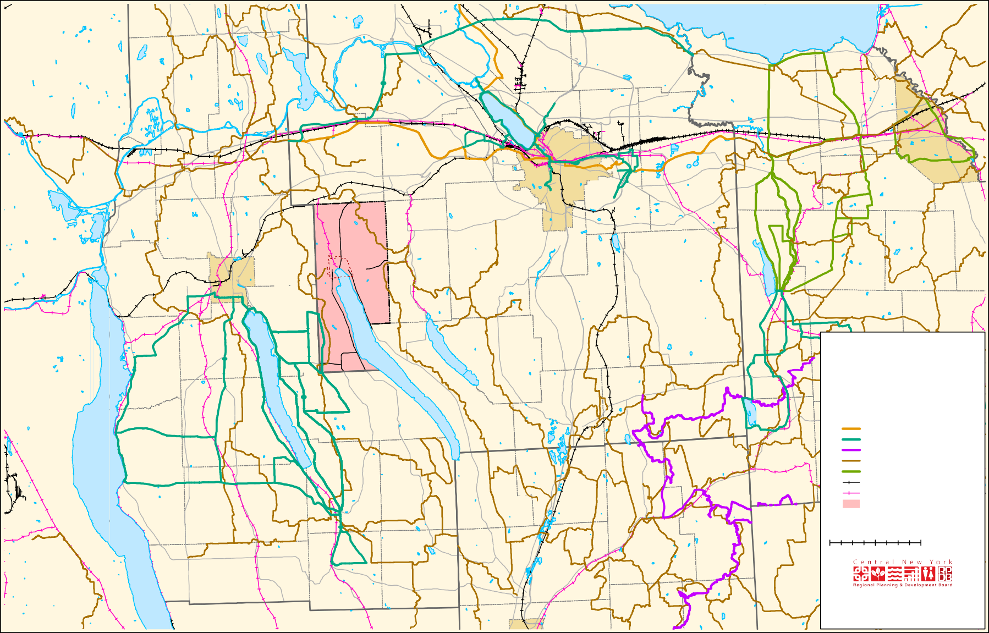
Figure 9: Regional Hiking and Biking Trails

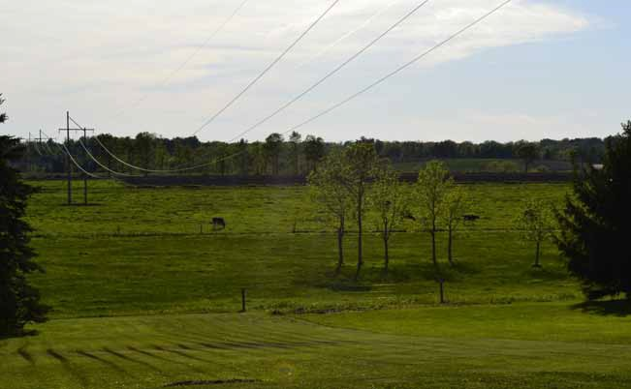
Scenic view of farmland, Skaneateles

CHAPTER 5: SkAnEATELES OPEn SPACE COnSERVATIOn LAnD PRIORITIZATIOn

In addition to scenic vistas and agriculture land, characteristics such as wetlands, forests, and parcels near Skaneateles Lake are significant areas to protect. A method for selecting priority sites was developed by the Skaneateles Open Space Committee in 2010. This provided an opportunity to numerically rank sites based on existing character, planning and zoning conformance and issues, proposed protections, location, and costs.

In 2016, CNY RPDB used parts of this strategy to develop a computer-generated method that improves the accuracy and validity of the site
identification and prioritization process. CNY RPDB generated a base map and identified all the parcels that were already protected from development or conserved through easements.

For the remaining parcels, several valued land
characteristics were selected by the CNY RPDB in cooperation with the Open Space Committee and were mapped using Geographic Information System (GIS) technology. A numerical rating was assigned to each characteristic. The mapping and layering of these characteristics provided
an opportunity to identify high priority sites for conservation purposes. This process is known as the Skaneateles Open Space Conservation Land Prioritization Model. The following bulleted list summarizes why the characteristics were selected.

- Quality of agricultural land: The farming industry, encompassing 12,205 acres and 40% of the overall land use in Skaneateles, has experienced development pressures and
increasing land prices, similar to many other areas in New York State. The preservation of farmland and agricultural industries is a primary planning

goal for the Skaneateles community. Agricultural soils were therefore identified and numerically rated based on their value. Land parcels were grouped within the following three categories: prime agricultural soils, soils of statewide importance, or land that was in an agricultural district or in agricultural use.
- Parcel size: Parcels with larger acreage received a higher numerical rating due to the increased value to the community (Figure 11).
- Location in the Skaneateles Lake watershed: Skaneateles Lake provides water for approximately 250,000 people in the Village and Town, the City of Syracuse, and other parts of Onondaga County. Many of the land-use activities in the watershed impact the water quality in Skaneateles Lake.
Land parcels in the watershed received a higher numerical rating than parcels outside of the watershed (Figure 2).
- Length of lake shoreline: Sites located along Skaneateles Lake have a greater value to the community. These sites, therefore, received a higher numerical rating.
- Proximity of the parcel to active recreation lands: Recreational lands such as public parks, public access to the lake waterfront, and hiking trails received a higher numerical rating. This helped to identify open space corridors, with the goal of providing connectivity between recreation lands and encouraging outdoor recreation.
- Percent slope: Areas with steep terrain received a higher rating because the potential for soil erosion and sediment loading in hilly terrain would impact local waterbodies (Figure 4).
- Proximity of the parcel to a sewer or water district or line: Parcels in close proximity to sewer or water infrastructure are generally easier to develop. Numerical values were therefore assigned if the site was located in or near a water or sewer district (Figure 7).

Length of stream corridor or lake shoreline:
Sites located along a tributary have greater value
to the community. These sites, therefore, received a higher numerical rating.
- Length of road frontage: Road frontage has greater value to the community because of increased access to protected areas and views.
- forested land: Tree roots stabilize soil particles and reduce the rate of erosion. Forested land received a higher rating because trees reduce
the amount of stormwater runoff, create sound buffers, provide cooling in the summer, and wind protection in the winter. Forested areas also provide timber harvesting jobs and support opportunities for tourism and recreation such as hiking and camping.
- Wetlands not delineated as State or federal: Wetlands are valued for their flood and stormwater control, surface water protection, groundwater recharge, erosion control, pollution treatment and nutrient cycling, fish and wildlife habitat, and recreational benefits (Figure 6).
- Historically significant structures or landscapes: Historic sites and structures were included in the prioritization model because of their value in shaping the personality and
characteristics of the town. The sites received a higher numerical rating if they were listed on the National Register of Historic Places or if they were identified by the Town Historian (Figure 12).
- Viewshed quality and extent: Viewsheds were included because of their value to the unique aesthetic characteristics of the community. Only
a limited number of notable views were included for the purpose of site prioritization but many additional views exist throughout the town.
- Proximity of the parcels to protected and public lands: ‘Protected lands’ refer to sites that are already protected from development through, for example, conservation easements. This category also includes federal or state wetlands. Close proximity to protected and public land was considered because of the value of access and connectivity for wildlife and recreational benefits.

Town of Skaneateles Open Space Plan October 19, 2016
37

Protected parcels were identified in the town and within one mile beyond the town border (Figure 8).

High quality soils on agricultural parcels were given the highest weight. Lower values were assigned
to the remaining natural and cultural conditions (Figure 11). The quality and extent of public views were also assessed and the values were incorporated into the final rating.

This approach provided an opportunity to identify, map, and prioritize valued sites throughout the town based on the protection of open space and agricultural lands, protection of Skaneateles Lake water quality, and preservation of wildlife habitat and recreation areas.

The final rating is displayed in a Conservation Suitability Map (Figure 10) which identifies the
ranked parcels as either some conservation value, more conservation value, and most conservation value. The parcels that scored the highest conservation value are indicated in dark green.
Parcels already protected from development are shaded in grey.

This computer-generated method provides an opportunity to identify high priority sites for conservation purposes. It should be noted, however, that this is only one of several tools that can be applied. There may be additional parcels that have great conservation value that should be considered based on factors such as availability and cost. To help with this assessment, the map in Figure 9 shows agricultural parcels that are greater than 20 acres. The parcels that are marked in green are areas that are assessed as agricultural land use and/or that appear to be farmed through visual analysis of aerial photographs.

TOWN OF SKANEATELES
Town of Camillus Town of Marcellus
ER RD
Suitability Analysis For Open Space Conservation

General Prioritization Based on Conservation Criteria

Lower Priority Moderate Priority Higher Priority Protected Lands
VISI
AR HILL RD

0 0.25 0.5 1 Miles [

Charlie Major Nature
Trail

EF321

Data obtained from the United States Geological Survey, the New York State Department of Transportation, and the Syracuse - Onondaga County Planning Agency. This map was created for planning purposes only. The CNYRPDB does not guarantee the accuracy or completeness of this map. Please see text for full disclaimer. Map created: August 2016.

VILLAGE OF SKANEATELES
EF175
`_20

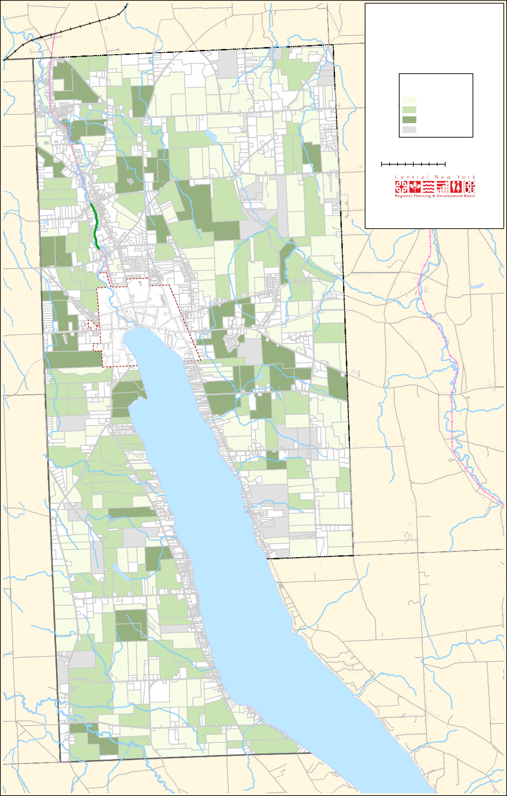

EF41A
SHORT RD

A@41

EF359
BENSON R

EF38A
RUSSELL
TARY RD
ALBRING RD

Skaneateles_T_SuitabilityAnalysis_RatingsReview_JG

Figure 10: Suitability Analysis for Open Space Conservation

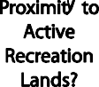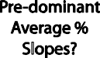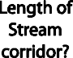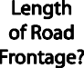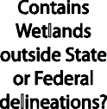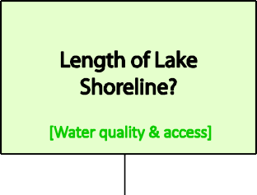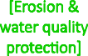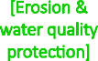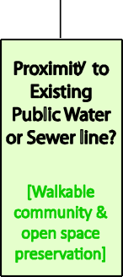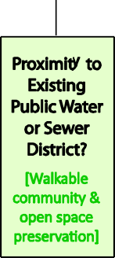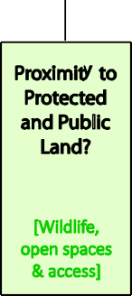
40
Town of Skaneateles Open Space Plan October 19, 2016

Figure 11: Weighted Diagram of Suitability Analysis Criteria

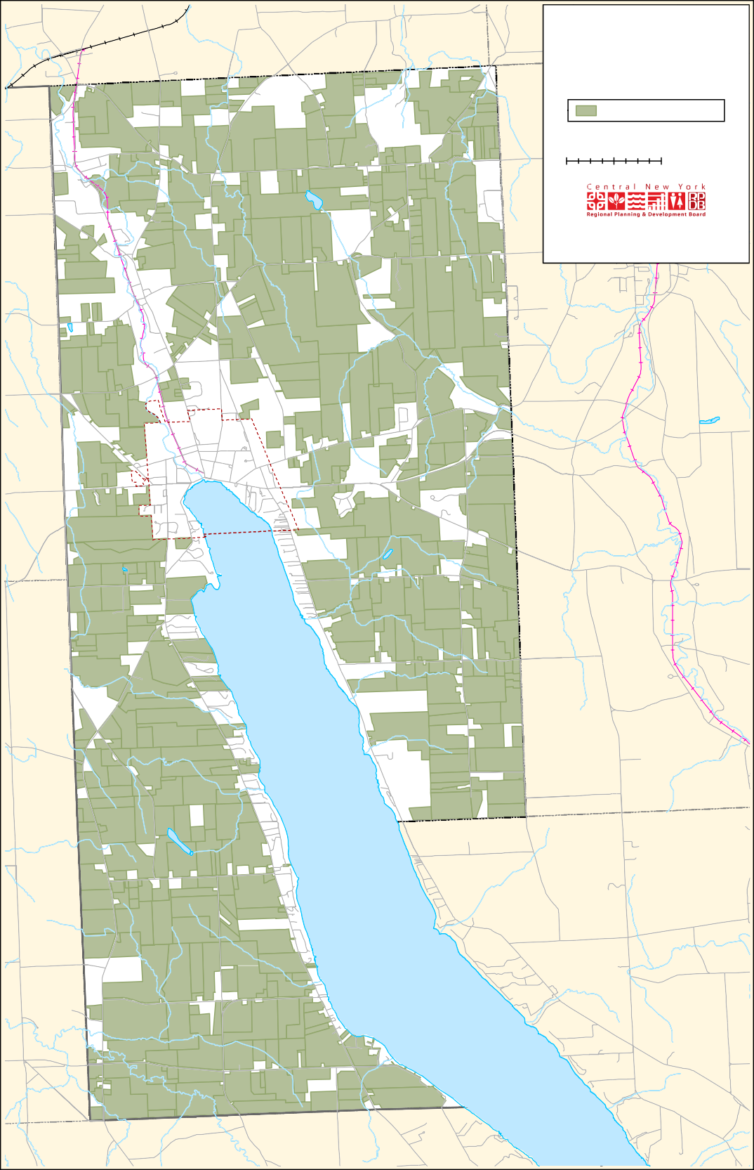
Town of Camillus Town of Marcellus
TOWN OF SKANEATELES
Agricultural Parcels
Parcels in Agricultural Use
0 0.25 0.5
1 Miles
[
EF
321
Data obtained from the United States Geological Survey, the United States Department of Agriculture, the New York State Department of Transportation, and the Syracuse - Onondaga County Planning Agency. This map was created for planning purposes only. The CNYRPDB does not guarantee the accuracy or completeness of this map. Please see text for full disclaimer. Map created: August 2016.
EF175
_`20
EF41A
@A41
EF359
EF38A
Skaneateles_T_Ag_JG
VISI
D
k
AR HILL RD

SHORT RD

RUSSELL

Figure 12: Agricultural Parcels
TARY RD
BENSON R
ALBRING RD

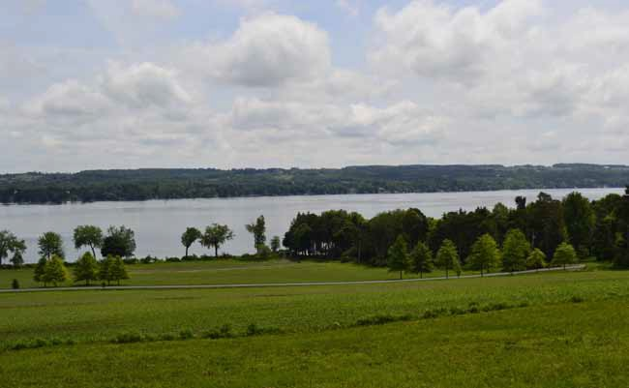
View of Skaneateles Lake, Skaneateles

CHAPTER 6: OPEn SPACE COnSERVATIOn TOOLS

Several options are available for conserving land in Skaneateles such as donating a conservation easement, donating conservation land, donating property to a land trust in order to generate conservation funds through resale options, making a bequest of property to a Land Trust as a provision in a landowners will, or selling the property to a land trust at less than fair market value. A few of these options are summarized on the following pages. Some of this information is based on a publication called, ‘Local Open Space
Planning Guide’ which was written by the NYS DEC and the NYS DOS. Funding options for financing open space protection and land acquisition are summarized in Appendix B.

Agricultural Districts
The Agricultural District Law establishes the authority for the Department of Agriculture and Markets to create agricultural districts comprised of farmland of 500 acres or more. A district is established by county legislative action which is initiated by a petition from the owners of the land. This is followed by certification by the Department of Agriculture and Markets in consultation with DEC and the Advisory Council on Agriculture.

According to the NYS Department of Agriculture and Markets, the purpose of agricultural districting is to encourage the continued use
of farmland for agricultural production. The Program is based on a combination of landowner

incentives and protections, all of which are designed to slow or prevent the conversion of farmland to non-agricultural uses. Included in these benefits are preferential real property tax treatment (agricultural assessment and special benefit assessment), and protections against overly restrictive local laws, government funded acquisition or construction projects, and private nuisance suits involving agricultural practices.³

The New York State agricultural and farmland protection program authorizes the Department of Agriculture and Markets to provide technical assistance to county agricultural and farmland protection boards, to develop guidelines for the creation of agricultural and farmland protection plans, and to administer planning grants and a farmland protection fund.

Conservation Easements
A conservation easement can be an effective tool for the permanent protection of private lands with valuable natural resources such as water quality, wildlife habitat, wetlands, or viewscapes. It is a legally binding agreement between a property owner and a land trust, conservation agency
or municipality. The easement limits future undesirable land uses on a parcel while allowing for traditional uses such as agriculture and forestry. Some, but not all, easements allow public access. An easement leaves the land in private ownership while providing land use protection that is stronger than the local zoning or land use laws. It restricts the level of development on a parcel of land without a land trust or other entity having to purchase the property outright.

An easement is recorded in the land records and become part of the title to the land.⁴ As such, it is a legal agreement that is transferred with any
future sale of the land. It provides an effective way to maintain land in safekeeping for the benefit
of future generations. Easements allow the purchaser to acquire partial rights to a parcel of land instead of acquiring all of the rights in fee
- http://www.agriculture.ny.gov/ap/agservices/agdistricts.html
- ‘Protection Your Land With a Conservation Easement’, Finger Lakes Land Trust, http://www.fllt.org/brochure-protecting-your-land-with-a- conservation-easement/
simple. Acquiring land in fee simple means you own all of the rights to that land. Conservation easements impose restrictions on the land and can readily be used to conserve open space, to protect valuable environmental areas, historic resources, and/or to provide educational benefits for the community.

Sections 49-0301 through 49-0311 of the Environmental Conservation Law (ECL) provide the authority for not-for-profits or municipalities to use conservation easements as land use tools.
According to the NYS DEC, an appraiser determines the value of the property rights given up by a landowner, and then the easement is purchased
or donated, resulting in a variety of tax benefits. When the state or a land trust accepts and holds a conservation easement it assumes responsibility for monitoring and enforcing the terms of the easement in perpetuity (forever). The easement
is recorded with the deed and is binding on future landowners.

Conservation easements can also reduce the resale value for the land owner. They restrict the number, type, and location of residential
dwellings and certain other buildings; restrict and sometimes prohibit quarrying and excavation of
Conservation Easement Benefits
- Land remains in private ownership.
- Easements remain with the property even if the land is sold or passed onto heirs.
- Easements are flexible and can be modified to meet landowner goals.
- They provide environmental protection and open space conservation benefits.
- Easement can also provide tax benefits for the landowner.
- Easements attract buyers that are looking for privacy and the benefit of protected land.

mineral resources; restrict dumping of solid and liquid waste; guide forestry activities under an approved woodlot management plan; and restrict or eliminate industrial and commercial activities, except those associated with agriculture.

Conservation easements do not necessarily permit public access to the protected areas unless specifically desired by the landowner and conservation organization; change the ownership of the land; or prohibit all subdivision. The property could be subdivided subject to the terms of the easement agreement.⁵

Property tax assessment is usually based upon a property’s market value, which reflects
the property’s development potential. If a conservation easement reduces the development potential of the property, it may reduce the level of assessment and the amount of the owner’s property taxes. Thus tax incentives may encourage people to preserve open space.

Sale or Donation of Conservation Easements The primary source of public funding available for the purchase of conservation easements is through New York State’s Farmland Protection Program. Landowners who are not eligible for
the purchase of development rights program may also decide to protect their land by donating a conservation easement in which case the value of an easement can be claimed as a charitable
deduction on state and federal income taxes. New York State implemented a Conservation Easement Tax Credit in 2006 to provide property tax relief to qualifying landowners. A conservation easement may also reduce estate tax burdens thereby easing intergenerational land transfer costs.⁶

Landowners whose land is restricted by a donated conservation easement can receive an annual state income tax credit equal to 25 percent of the

- Conservation Easement Fact Sheet, New York Agricultural Land Trust
- ‘A Vision for the Canandaigua Lake Watershed’. Finger Lakes Land Trust. http://www.fllt.org/content/uploads/2015/02/Conservation-Plan- Canandaigua.pdf
combined town, county and school taxes paid on the land during the previous tax year. The credit is capped at $5,000 per year for each qualifying landowner.

A donated conservation easement is a long process. It normally takes between eight months to a year to complete and property owners are faced with transaction costs including legal fees, baseline report preparations, recording fees and future stewardship expenses. Organizations such as the Finger Lakes Land Trust and the New York

COCS studies show that working lands generate more public revenues than they receive back in public services and their impact on community funds is similar to that of other commercial and industrial land uses.

Agricultural Land Trust (NYALT) may be able to help. In Skaneateles, for example, once the eligible properties are identified and a list of potential projects has been established, NYALT would apply to the Onondaga County Agricultural Council for funding to complete as many of the projects as possible.

Marion Myers organized 20 family and childhood friends to protect a 64-acre parcel of land on Canandaigua Lake in the nearby Town of South Bristol, New York — a beautiful area with evergreens and deciduous trees and a lovely view overlooking the lake. The land had been in the family since 1866. They formed the Richard M. Morse Conservation Club, pooled their financial resources, and purchased the property. In 2005, they donated a conservation easement to the Finger Lakes Land Trust to ensure the future of the land. The sloping land includes a pond and primitive cabin as well as the south rim of Seneca Point Gully and the club members now share in the enjoyment and management of the land.

The easement allows for the selective harvest of timber, the maintenance of the pond, trails, and cabin, and ensures that the land will not be divided.

Skaneateles has granted three conservation easements on town land. They are the Butters Farm Conservation Easement, the Lavery Rickard Road Conservation Easement, and the Meiers Northwest Townline Road Conservation Easement.

- The Butters Farm Conservation Easement was granted by the Town in July 2005. The easement restricts development of the open space land
and allows use only for agriculture, forestry, recreation, protection of natural resources, or similar conservation purposes. The easement requirements are identified in Skaneateles Town Code Section 148-9H and are pursuant to Section 247 of the General Municipal Law and/or Sections 49-0301 through 49-0311 of the Environmental Conservation Law.

- The Lavery Rickard Road Conservation Easement, granted in October 1996, prevents future development on 14 acres. Ordinarily if the Town designates hiking trails or other use, the general public could use it. This property, however, is land-locked and is not accessible
without crossing the other acreage of the property owner. The property contains natural, ecological, and scientific values of great importance. It
also contains significant wildlife habitat, plants, Skaneateles Lake tributaries, prime agricultural soils and scenic views.

- The Meiers Northwest Townline Road Conservation Easement was granted by the Town in August 2006. The easements, including portions of three lots in a 55.5 acre property, restricts development, preserves open space and provides conservation value to the Town. The easement allows agricultural use but does not allow any structures to be built. It allows land use only for forestry, recreation, protection of natural
resources, agricultural and farming purposes.

Cost of Community Services Analysis
Several New York State municipalities have determined the value of various land uses through a method called the Cost of Community Services (COCS). Land uses impact population trends, community character, priorities established by
the local government, the level of tourism, and the types of municipal services provided. As with many municipalities, a goal for Skaneateles is to find a comfortable balance between agricultural
productivity, affordable housing, economic growth, historic preservation, and land conservation.

The American Farmland Trust (AFT) developed a method in the mid-1980s whereby the fiscal
contributions of differing land use categories could be evaluated. Through the COCS, relationships of costs (municipal and educational services) and revenues (taxes and fees) of existing land uses are compared to determine the fiscal contribution
to the municipality. Municipalities have used this method to provide a baseline evaluation that is used by elected officials and community leaders to make land use and policy decisions.

The COCS can be an efficient and cost-effective way for a municipality such as Skaneateles to assess the net contribution of its conservation goals in relation to residential, commercial, industrial,
and agricultural land use. COCS is determined by analyzing financial data and assigning the cost of municipal services (such as water and sewer) for various land uses. The results are displayed as ratios of annual revenues and annual expenditures for each land use category. This approach is often used to dispel the common belief that farmland, forests, and open space should be converted to other uses in order to achieve financial stability for the municipality.

The process used to compile a COCS requires thorough research and local level participation to ensure that correct interpretations are made regarding land uses. This method has been used in many communities throughout the United States as an effective way to avoid urban sprawl
and the unnecessary loss of open space, increased

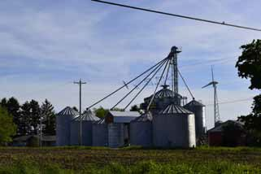farmland/open space) are usually well below 1.0, representing a net tax gain for the municipality.⁸

Several communities in New York State have used the COCS to determine the fiscal contribution of existing land uses including the towns of Victor, Gorham, and Rochester, and the counties of Sullivan and Green.

Grain silos and wind turbine in Skaneateles

demand for public services, and traffic congestion. Residential land use must be subsidized by other community land uses, so converting agricultural land to residential land use should not be seen as a way to balance local budgets.

COCS analysis has shown that: “What is unique about COCS studies is that they show that agricultural land is similar to other commercial and industrial uses. In nearly every community studied, farmland has generated a fiscal surplus to help offset the shortfall created by residential
demand for public services. This is true even when the land is assessed at its current, agricultural
use. However, as more communities invest in agriculture, this tendency may change. For
example, if a community establishes a purchase of agricultural conservation easement program, working and open lands may generate a net negative.”⁷

Nearly all of the COCS research studies conducted by the Pennsylvania Land Trust Association show that the ratio for
residential land is above 1.0, signifying that residential land results in a net drain on local government budgets. On the other hand, the ratios for the other two land
use categories (commercial/industrial and

- American Farmland Trust, NRCS Farmland Information Center, 2010, http://www.communitypreservation.org/community_services.pdf

Critical Environmental Areas
The State Environmental Quality Review Act (SEQRA) is designed to incorporate the
consideration of environmental characteristics into the existing planning, review, and decision making processes of government agencies. The SEQRA practice, which provides information about how a proposed project would affect the environment,
is designed to help state and local agencies make better decisions based on environmental considerations. SEQRA helps to ensure that environmentally sensitive areas and significant open space resources will be considered when a proposed project is reviewed. Based on this
review, they may be protected by governmental or private initiative.⁹

An opportunity for the protection of open space is the designation of a critical environmental area (CEA). CEAs, available under SEQRA 617.14 (g), is a specific geographic area within the community that contains sensitive or unique features that require protection. To be designated as a CEA,
an area must have one or more of the following characteristics:

- It can be a benefit or threat to human health;
- It can be a natural setting such as open space or areas of aesthetic or scenic quality;
- It can have agricultural, social, cultural, historic, archaeological, recreational or educational values;

- Conservation Tools.org, Pennsylvania Land Trust Association, http:// conservationtools.org/guides/15-cost-of-community-services-studies
- Local Open Space Planning Guide. NYS DEC and NYS DOS. 2007.

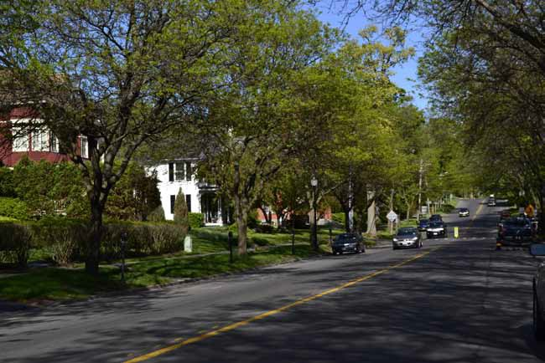
East Genesee Street, Skaneateles

- It can have an inherent ecological, geological or hydrological sensitivity to change that may be adversely affected by any change.¹⁰

To designate a CEA, a local agency or governing body must give written public notice and hold a public hearing. A map of the boundaries of the CEA, a written justification supporting the
designation, and proof of the public hearing are then filed with the DEC in Albany and regional office and any other agency that is regularly involved in approving, undertaking or funding actions in the municipality.

According to the NYS Department of Environmental Conservation, designation of a CEA does not substitute for or provide governmental protection afforded by land use controls such as zoning, or acquisition of restrictive easements,
or purchase and direct management. CEAs, therefore, cannot be considered as a type of

- NYSDEC http://www.dec.ny.gov/permits/6184.html)
development control. The value of the CEA is that the designation gives the sponsor of an action
in or adjoining the area a greater value for the importance of the area. The CEA may require additional attention when reviewing a proposed action but it does not create a new jurisdiction for the designating agency.

Deed Restrictions
Developers of residential properties may choose to voluntarily restrict the use of part of the property in order to provide open space. This can be accomplished through deed covenants,
restrictions and easements. For example, the deed may specify joint ownership with neighboring lot owners so that they all have access to a common area. In this case, an easement could indicate that the common area may not be developed except for activities relating to open space and recreation.

Prior to the use of easements to preserve open

space, landowners can imposed deed restrictions when selling a portion of their property to ensure that subsequent owners would not use it for objectionable purposes such as maintaining livestock or cutting of mature trees on the property.

Landowners may develop formal or informal agreements without involving a conservation organization or government agency. These arrangements, for example, could be in the form of verbal agreements between neighbors, deed restrictions, or a contract among the members of a homeowners association.

A primary disadvantage of using deed restrictions is that a third party (such as a land trust or
bank) isn’t available to monitor and enforce the restriction. There is very little security that the land will be permanently protected, as the restrictions depend on the interests of the private parties. A third party isn’t available to legally enforce the agreements and there are no tax advantages for landowners.

Land Acquisition
Property acquisition and management of a site as open space is another way that municipalities can maintain open space for conservation purposes. Section 247 of the General Municipal Law authorizes local governments to expend public funds to acquire interests or rights in real property to preserve open space or open areas. This section also provides that after acquisition, the valuation of the open space areas for real estate taxation purposes will take into account and be limited by the restriction on the future use of the parcel.¹¹

Land transfer techniques may include fee simple acquisition and acquisition of partial interests or rights through an easement whereby a landowner may own all of the rights on the property or only some of them.

Expansion of recent land purchases by the NYS

- Insert footnote: “Local Open Space Planning Guide”, 2007, NYS DEC and NYS DOS
DEC in partnership with the Finger Lakes Land Trust is helping to preserve the Camillus Valley/ Nine Mile Creek area. This is an ecologically sensitive valley that supports a wide diversity of breeding bird and migratory bird species. The area is also a widely used trout stream. The project encompasses the Nine Mile Creek Valley, running from Otisco Lake to Onondaga Lake. It includes enhancing the DEC administered Camillus Forest, the Nine Mile Creek Critical Environmental Area, the Erie Canal Corridor, and the Water Trail in the Towns of Camillus and Marcellus. The project will buffer important attributes from development and provide public waterway access.

The Skaneateles Highlands encompass the scenic terrain extending from Carpenter’s Falls to the west to the Staghorn Cliffs to the east. This southern portion of the Skaneateles Lake watershed is valued for its natural resources, such as wetlands in Bear Swamp Creek, steep wooded hillsides, and sections of undeveloped shoreline. Public lands in this area include Bear Swamp State Forest, shoreline owned by the City of Syracuse, a park owned by the Town of Scott, the Central New York Land Trust’s Ripley Hill Nature Preserve, and several properties owned by the Finger Lakes Land Trust. According to the NYS DEC, “These undeveloped lands play an
important role in helping to maintain the drinking water supply for the City of Syracuse. Much of the area is also recognized by the National Audubon Society as one of the state’s Important Bird Areas.

The Staghorn Cliffs are also singled out for recognition due to their unique fossil formations, as well as their scenic beauty. Recreational resources include Bear Swamp State Forest’s extensive multi-use trail system, opportunities for hunting, fishing, and wildlife viewing, and boating and paddling on Skaneateles Lake. A proposed expansion of existing recreational trails would add miles of hiking and skiing trails on the east side
of the lake. Select acquisitions as well as the use of conservation easements are needed to ensure the integrity of this landscape while enhancing opportunities for outdoor recreation.”

The Finger Lakes Land Trust in partnership with the NYS DEC recently approved the transfer of a 15 acre parcel with 2,300 feet of frontage on the Owasco Inlet in Cayuga County. The parcel is located within the Owasco Flats, an area of wetlands and cropland located just south of Owasco Lake within the town and village of
Moravia. The Land Trust purchased the property in 2008 through a grant from the Fred L. Emerson Foundation. The land has been donated to DEC to enhance fishing, hunting, hiking, kayaking and other outdoor recreational pursuits.

land Trusts
Land trusts are private non-profit organizations that is managed by local citizens. The trust can be formed to acquire land or interests in land to protect open space, recreation resources, scenic vistas, farmland, or unique natural habitats. The
Finger Lakes Land Trust, the Central New York Land Trust, and The Nature Conservancy and examples of well-known land trusts.

Land trusts can accept donations of land, funds to purchase land, the development rights that permanently limit land development, or they can purchase land for permanent protection.
They often work in partnership with government
agencies in their land conservation efforts and pool their financial and staff resources. While they work to protect large landscapes, they also help citizen-based groups focus on smaller local initiatives. The Finger Lakes Land Trust has worked with partners to secure more than 16,000 acres
of the region’s undeveloped shoreline, farmland, gorges and forests.

Land Use Regulatory Tools

Zoning
Local governments such as Skaneateles use zoning to guide land use decisions, and to regulate the intensity or density of the use and the siting of development on land parcels. Through zoning, municipalities can identify and regulate compatible and incompatible uses and are able to protect property values and promote economic, public health, safety and welfare of local citizens.

Zoning regulations include a zoning map that divides the municipality into districts or zones.
The maps have descriptive explanations of the regulatory requirements for each of the zones. The Zoning Board of Appeals may issue a variance to
a property owner when land use is proposed that doesn’t comply with zoning regulations. Overlay zoning, large lot zoning, performance standard zoning, and special use permitting are examples of

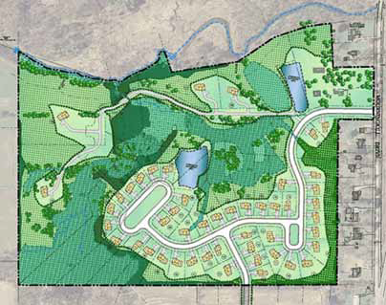
Source: Mourning Kill Meadows Conservation Subdivision, Lansing Engineering, http://www.lansingengineering.com/ services/mourning-kill-meadows/

techniques that can be used for land conservation purposes.

Planned Unit Development
A planned unit development (PUD) provides for flexibility in the planning and development of a tract of land while also allowing for mixed uses - usually commercial and residential. PUDs describe a type of development and the regulatory process that permits a developer to meet the land use goals of the community without being bound
by existing zoning requirements. A PUD could be used, for example, to encourage open space through the clustering of buildings, incorporate
different building types, promote energy-efficiency systems, or to create a variety of housing types built around a commercial center. An application for a PUD district is typically reviewed by the planning board, and a recommendation is made to the legislative body.

Transfer of Development Rights
Transfer of development rights (TDR) is a ‘Smart Growth’ tool that can be used to manage land development. This technique encourages the voluntary transfer of growth from places where a community would like to see less development
(called sending areas) to areas where a community would like to see more development (called receiving areas). The sending areas, for example, can be environmentally-sensitive properties, open space, agricultural land, wildlife habitat, or historic landmarks. The receiving areas are places that
the general public has agreed are appropriate for extra development because they are close to jobs, shopping, schools, transportation and other urban services. The sending areas are typically located
in rural land and receiving areas are in or adjacent to cities or populated areas. TDR allows for the exchange of zoning privileges from areas with low population needs (such as farmland) to areas of high population needs, such as downtown areas. These transfers allow for the preservation of open space and historic landmarks, while allowing urban areas to expand and increase in density. The Town
of Skaneateles has had a Transfer of Development Rights provision in its zoning for several years (see Section 148-9J), but it has never been used.

TDR opportunities in Skaneateles may be limited. It has been a difficult concept to implement in other communities because it requires a very specific
set of circumstances for success and requires a stable real estate market. At times, there may be problems arranging for a bank to facilitate buying or selling density credits. The area that is set aside to receive the extra density must be able to accommodate more units. In addition, if
the area that is receiving the extra density credits can obtain increased density through another means, such as zoning variances, TDRs will be less attractive.¹²

The Onondaga County Town of Lysander recently eliminated their TDR program and replaced it with an incentive zoning district in select locations.
The general intention of the district is to allow more intense development than allowed by underlying zoning in certain locations, in return for implementation or payment toward certain designated community improvements such as
infrastructure, parks, and farmland and open space preservation.

In 2000, a $9.5 million bond issue was also approved by the voters of Warwick (Orange County New York) to save farmland through the voluntary purchase of the development rights of farm properties and open space. The land remains farmland in perpetuity, farmers receive monies which enable them to modernize their operations, and they don’t feel it’s necessary to sell to developers to make ends meet.

In Monroe County, several municipalities also passed bonds to maintain open space by purchasing development rights through conservation easements on farms. A local
planning process in the mid-1990s led the Town of Pittsford to the goal of preserving 2,000 acres
- Local Open Space Planning Guide. NYS DEC and NYS DOS. 2007.

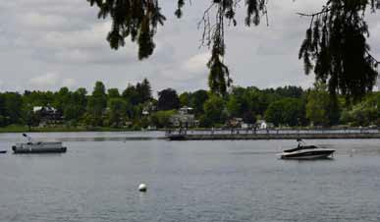municipalities about how to implement local TDR programs.

Skaneateles Lake Pier
of open space. A town-wide inventory identified 1,200 acres on seven viable, priority farms in addition to several hundred acres of sensitive lands of ecological or scenic importance. The town authorized a $9.9 million bond to purchase key parcels and development.¹³

BFJ Planning in association with the NYU Rudin Center and Johnson & Asberry is producing a Transfer of Development Rights Toolbox to assist New York State municipalities in implementing TDR programs. The project is funded jointly
by the New York State Energy Research and Development Authority (NYSERDA) and New York State Department of Transportation (NYSDOT).
The primary objectives are to demonstrate the benefits of TDR in coordination with smart
growth principles and to provide information to
- ‘A Vision for the Canandaigua Lake Watershed’. Finger Lakes Land Trust. http://www.fllt.org/content/uploads/2015/02/Conservation-Plan-Canandaigua. pdf
Subdivision Regulations Municipal subdivision regulations determine the way land is divided into smaller parcels, and can be used
to ensure that adequate services and facilities will be considered for new development. These regulations help to ensure the existence of desirable
conditions, such as the safety of building locations on a lot, the adequacy of road design and layout, access for emergency
vehicles, adequate water supply, a drainage plan and sewage disposal.

Subdivision regulations can include provisions which help to accomplish open space conservation through cluster development, planned unit development, dedication of recreation land or imposition of fees to purchase recreation land,
as described below. Subdivision regulations, for example, can protect open space resources such as wetlands, steep slopes, and stream buffers
by requiring that new subdivisions be laid out in a manner that will avoid constrained areas.
A municipality’s subdivision regulations should exclude areas such as steep slopes and wetlands from density calculations.¹⁴

Site Plan Approval
A zoning ordinance may require developers to be subject to a site plan approval which involves a
- Ibid.

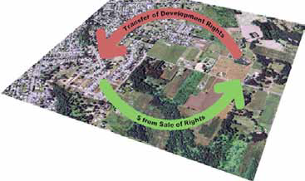
Source: Oregon Department of Land Conservation and Development, https://www.oregon.gov/LCD/pages/tdr_pi- lot_program.aspx

review of the design for a proposed development on a particular parcel of land. This process can be used to ensure that development in a given area will be consistent with existing development. Site plan approval can, for example, require vegetative screening of buildings or it can address parking requirements.

Site plan approval also can be used to protect scenic vistas. For example, if a scenic agricultural area can be viewed from a highway, the zoning ordinance can require site plan reviews to ensure that proposed developments will not interfere with those views. Site plan approval, unlike subdivision regulations, is not concerned with how new lots are created. Instead, it is concerned with how development occurs on a single lot. It
is commonly used to affect the site design for a proposed development such as a retail store or a service station, but this approach can only address site open space issues on a given parcel or site.¹⁵

Conservation Subdivision
Skaneateles and many other agricultural communities are facing development pressures as a consequence of the attraction of scenic farmlands and waterfront land for residential housing. Rural residential development, in its conventional form of two acre lots subdivided out of large agricultural parcels and commercial strip
malls along rural roadways, can produce sprawling suburban developments that consume large areas of open space and drastically alter a town’s rural- agrarian character. Protection of scenic open space, sustainability of agricultural land, and lake protection are priority issues addressed by the Skaneateles community.

The conservation subdivision process is an effective tool that could be strengthened for open space protection in Skaneateles. This method of regulating the subdivision of land is intended to preserve or protect natural, scenic, historic, or

- Local Open Space Planning Guide. NYS DEC and NYS DOS. 2007
cultural features of value to a community while allowing flexibility in the overall development design and layout of major subdivisions (4 or more lots).

The Town of Skaneateles has had conservation subdivision provisions, described as “open space subdivisions,” in its zoning and subdivision regulations since 1996. These regulations were
strengthened in 2005. (See the Town Zoning Law, Sections 148-9-C and 148-9-G). However, they have not produced significant results in protecting the rural- agrarian character of the town.
Improvements in the open space subdivision process and standards are needed to make it more effective and it should also be actively publicized to landowners and the community (who appear to be largely unaware of its existence). A critical first step in conservation subdivision design is to walk the property with a landscape architect, property owner or developer, neighbors, and planning board members to identify significant natural or cultural resources. These contribute to the “conservation analysis,” which is an essential part of the sketch plan review process. It leads to a dialogue between the property owner(or developer) and the planning board about conserving the land that is most valuable for conservation in conjunction with the development approval process. This, in turn, leads to a collaborative process between
the landowner and the Town to develop a plan that allows development but is also is protective of open space resources. If the open space subdivision provisions are not used, the result can be conventional subdivisions which do not support the community’s desire to protect the rural- agrarian character of the town.

The conservation method of subdivision of land is intended to allow for the preservation or protection of natural, scenic, historic, or cultural features of value to the community
while also allowing flexibility and an opportunity for developers to initiate creative solutions to

protecting important community resources such as steep slopes, scenic views, prime agricultural soils, trail corridors, stream corridors, wetlands, woodlands, and historic sites. Smart planning strategies such as conservation subdivision design result in less open land being consumed and less money spent by municipalities on infrastructure and community services than would be spent as a result of conventional subdivision design.

Recreation Land
According to the NYS DOS, certain land use regulations can require developers to set aside a percentage of their land for recreation or
parkland purposes or to put an equivalent amount
of money into a trust fund for the acquisition or improvement of recreational or parkland. The exact percentage can be determined by the planning board and the amount of money may be determined on a per lot, per acre or other reasonable basis. In some communities, these contributions exceed several thousand dollars per lot. A municipal Planning Board also may
determine whether or not the land that is being subdivided is suitable for recreational or parkland and whether or not there will be a need for recreational or parkland on the parcel.¹⁶

- Local Open Space Planning Guide. NYS DEC and NYS DOS. 2007

APPEnDIx A: DEFInITIOnS

Agricultural Districts
New York’s Agricultural District Law (Article
25-AA PDF of the NYS Agriculture and Markets Law) was enacted in 1971 in order to help keep farmland in agricultural production. Districts help to protect agriculture by discouraging the conversion of farmland to non-agricultural land uses. The Onondaga County Agricultural Districts web page describes the program and its benefits, provides current agricultural district maps, links,
reports, and the process and materials for adding or removing property from an agricultural district. http://ongov.net/planning/agdist.html

Best Management Practices
A Best Management Practice (BMP) is defined as a method, measure or practice determined to be the most practical and effective in preventing or reducing the impact of pollutants generated by nonpoint sources. BMP’s include structural and non-structural controls, and operation and maintenance procedures. For example, some
commonly implemented BMP’s include diversion ditches, grassed waterways, fencing, roof water management, and strip-cropping.

Development Rights
Land ownership normally consists of a collection of different rights and when someone purchases property, they purchase all of the rights that might be associated with the land. Owning a development right means that you own the right to build a structure on the parcel. Development
rights may be voluntarily separated and sold off, or donated separately from the land.

Ecosystem-based Management Ecosystem-based management (EBM) is a method of managing human activities and natural resources in a manner that supports healthy and productive ecosystems. The goal of
EBM is to promote a comprehensive strategy for natural resource management that evaluates
and considers the variables (such as agriculture, forestry, and wetlands) that interact within an entire ecosystem.

North Country Trail System
The NCTS is America’s longest National Scenic Trail. It stretches 4,600 miles from New York to North Dakota, linking 7 states, 10 National Forests, and more than 150 public lands.

Agriculture Preservation Reserve Fund Committee members discussed the status of the Agriculture Preservation Reserve Fund and the benefits of local code to give greater control to shoreline municipalities. Draft legislation is available.

An interesting article about this is located here - http://skaak.org/the-areas/dunning-tract/ Information about land trusts is found here - http://www.cnylandtrust.org/preserves.html#SCR

The Central New York Land Trust
The Central New York Land Trust is a private, nonprofit organization dedicated to protecting vital natural areas in Central New York for the health of the environment and the enjoyment of the public. Since its founding in 1972, the Central New York Land Trust has permanently protected more than 2,600 acres in a network of 47 nature preserves.
For more information visit the Trust’s Web site at http://cnylandtrust.org/.

Farmland Classification
Farmland classification identifies map units as prime farmland, farmland of statewide importance, farmland of local importance, or
unique farmland. It identifies the location and extent of the soils that are best suited to food, feed, fiber, forage, and oilseed crops. NRCS policy and procedures on prime and unique farmlands are published in the “Federal Register,” Vol. 43, No. 21, January 31, 1978.

Fee Title Acquisition
According to the Department of State, fee simple or fee title acquisition is the purchase of the fee title interest in a parcel of land. A purchaser can acquire a fee title interest in the property except for any rights in the property that already may have been transferred to some other third party. Preserving open space through fee title acquisition allows for the protection of the purchased land.
However, purchasing all of the rights and interests in a parcel may be expensive. In addition to obtaining funds for purchasing the land, funds for its management and maintenance on a continuing basis also must be provided. Types of fee title acquisition include the following¹⁷:

- Land can be purchased at its fair market value.
- Real property can be sold below the market value to a conservation organization or a municipality. This is referred to as a “bargain sale.” The difference between the market value and the reduced price may qualify as a charitable deduction from income taxes.
- An installment sale involves the sale of real property over a period of years. This allows the seller of the land to defer, and possibly reduce, the tax burden by spreading out the income from the sale.
- Land can be sold with an option that allows the seller to continue to use the property during his or her lifetime. This allows the landowner to receive the income now and then have the land transferred when he or she dies.

Flooding Frequency
According to the Natural Resource Conservation Service, flooding refers to the temporary inundation of an area caused by overflowing streams, by runoff from adjacent slopes, or by tides. Water standing for short periods after rainfall or snowmelt is not considered flooding, and water standing in swamps and marshes
is considered ponding rather than flooding. Frequency is expressed as none, very rare, rare, occasional, frequent, and very frequent. “None”
of flooding is nearly 0 percent in any year. Flooding occurs less than once in 500 years. “Very rare” means that flooding is very unlikely but possible under extremely unusual weather conditions.
The chance of flooding is less than 1 percent in any year. “Rare” means that flooding is unlikely but possible under unusual weather conditions. The chance of flooding is 1 to 5 percent in any year. “Occasional” means that flooding occurs infrequently under normal weather conditions. The chance of flooding is 5 to 50 percent in any year. “Frequent” means that flooding is likely to occur often under normal weather conditions. The chance of flooding is more than 50 percent in any year but is less than 50 percent in all months in any year. “Very frequent” means that flooding is likely to occur very often under normal weather conditions. The chance of flooding is more than 50 percent in all months of any year.

480-a Forest Tax Law¹⁸
New York State enacted the 480-a Forest Tax Law in 1974. It increases the likelihood of a more stable forest economy by encouraging land owners to engage in the long-term management of woodlands to produce forest crops. Any tract of forest land is eligible if it contains at least 50 contiguous acres, exclusive of any portion not devoted to the production of forest crops. Also, a timber harvest conducted within three years
prior to application must have been conducted in accordance with a thorough forest management program. Any owner of forest land may apply whether he or she is an individual, private corporation, industry, partnership, association, firm, trust, estate or any other private legal entity, excluding government entities.

This opportunity is beneficial for forest land owners if they are willing to commit land to the production of forest crops and to follow a
management plan for the next ten years beginning each year that they receive a tax exemption.
Tax savings may vary considerably for different properties. An owner must first determine the

means that flooding is not probable. The chance
18 Adapted from the NYS DEC website: http://www.dec.ny.gov/
- Local Open Space Planning Guide. NYS DEC and NYS DOS. 2007 lands/5236.html

likely exemption to apply to his or her property and estimate the resultant tax reduction, if any. It is possible that there would be no savings. If this analysis shows that a tax reduction can be obtained, a forester should be consulted for
professional advice about the approximate costs of preparing a forest management plan and making investments in the forest which may be required by the plan. The forest management plan contains maps, tables and written text, the boundaries and size of the forest, what kinds and sizes of trees it contains, and what needs to be done to produce and harvest forest crops.

New York Agricultural Land Trust
The New York Agricultural Land Trust is a 501(c)
(3) non-profit organization established in 2006 by farmers, for farmers and their communities, to help conserve important working farm and forestlands. NYALT is a statewide organization
currently assisting farmers in the Central New York region of New York State to implement farmland protection projects funded by the New York State Department of Agriculture through its farmland protection grant program. This program, described here, pays farmers for their non-farm development rights.

Their mission is to conserve working farmland and promote a greater appreciation for the
agricultural and forested lands and their associated natural resources that enrich our communities
and connect future generations to the land, locally and statewide. NYALT is currently working with municipalities and farmers in Cayuga, Montgomery, Onondaga and Seneca Counties. NYALT works with landowners, at their request, to protect the working landscapes important to Upstate New York’s rural agricultural economy and quality of life. NYALT’s conservation projects conserve high-quality farmland and supporting
woodlands, with projects ranging from dairy farms to diversified farming operations. In all cases, the farmers and landowners want to conserve their land for the next generation. They know that once
good land is lost to development, it will never come back into agriculture. These farmers are creating a legacy, ensuring that their land will be available for agriculture in the future.

As a land trust, NYALT works with landowners to meet their land conservation goals. Some
landowners want to tap into the equity of the land while maintaining ownership of the farm by selling their non-farm development rights via New York State’s farmland protection grant program. Others use grant funding to help transfer the land to
the next generation or diversify their operations. NYALT works in partnership with the farmland protection boards of local towns and counties who sponsor the grant application to New York State Department of Agriculture’s Farmland Protection Program.

New York State Farmland Protection Program
Conservation easements can be either sold or donated. The primary source of public funding available for the purchase of conservation easements is through New York State’s Farmland Protection Program. Landowners who are not eligible for the purchase of development rights program may also decide to protect their land by donating a conservation easement. Provided that certain criteria are met, the value of a donated conservation easement can be claimed as a charitable deduction on state and federal income taxes. Also, New York State implemented a Conservation Easement Tax Credit in 2006
to provide property tax relief to qualifying landowners. Landowners whose land is restricted by a donated conservation easement can receive an annual state income tax credit equal to 25 percent of the combined town, county and school taxes paid on the land during the previous tax year. The credit is capped at $5,000 per year for each qualifying landowner. Finally, a conservation easement may reduce estate tax burdens thereby easing intergenerational land transfer costs.¹⁹

- ‘A Vision for the Canandaigua Lake Watershed’. Finger Lakes Land Trust. http://www.fllt.org/content/uploads/2015/02/Conservation-Plan-

New York State Open Space Conservation
Plan
The NYSDEC and the NYS Office of Parks, Recreation and Historic Preservation (NYS OPRHP) are co-lead agencies of the New York’s Open Space Conservation Plan, a plan that serves as a blueprint for the State’s land conservation efforts to increase protection of the State’s significant natural, scenic, recreational, historic and cultural resources. By law, the plan must be reviewed every three years to adapt to shifting conservation priorities. The New York State Open Space Conservation Plan Regional Advisory Committee (RAC) is responsible for this. There are 21 RAC members that include representatives from each of Region 8’s eleven counties as well as at-large members. They are charged with providing input to update the previous Open Space Conservation Plan and to identify the types and locations of open space resources and various open space conservation tools and methods. In addition, the regional committee provides recommendations on policies, such as stewardship, and regulations. In 2014, the committee released a draft update to the 2009 Plan.

Onondaga County Agriculture Council The Council was formed in May 2012. Onondaga County Executive Joanie Mahoney tasked
the group with helping to ensure that county government is working to promote and preserve Onondaga County’s farming community. The Council helps to develop strategies and programs to promote local food production and strengthens and enhances connections between the County’s urban core and rural, agricultural areas. The Council works to review, improve and develop
pro-agriculture, farming friendly policies and regulations that promote urban agriculture. This work is designed to make it easier and more likely for local farms to open and stay in business in Onondaga County. http://www.ongov.net/ executive/agcouncil/

Canandaigua.pdf

Property Transfer Tax
A transfer tax refers to a tax (or transaction fee) required during the passing of ‘title to property’ from one person (or entity) to another. The tax is calculated at a rate of two dollars for each $500 of consideration. An additional real estate transfer tax (sometimes referred to as the “mansion tax”) of 1% of the sale price applies to residences where consideration is $1 million or more. The tax is paid by the grantor (seller). However, if the grantor doesn’t pay the tax, or is exempt from the tax, the grantee (buyer) must pay the tax. Property tax laws are difficult to pass and only approximately 12 municipalities in New York State have used
this as a way to generate local funds. Most are located in the Hudson Valley and on Long Island. Municipalities in Suffolk, Norfolk and Duchess County have generated funds by using a property transfer tax.

Skaneateles Lake Watershed Agricultural Program
The Skaneateles Lake Watershed Agricultural Program (SLWAP) works to implement cost- effective, innovative programs for the farming community to protect the high drinking water quality standards of Skaneateles Lake. The City of Syracuse established the SLWAP in 1994 as an
alternative to a costly filtration system required by the 1986 Amendments to the Safe Drinking Water Act. SLWAP is a voluntary program spearheaded by the Onondaga County Soil and Water Conservation District (SWCD), and serves portions of Onondaga, Cortland, and Cayuga Counties within the watershed. SLWAP served as a pilot for the Agricultural Environmental Management program (AEM) statewide by producing the Whole Farm Plan.

The SWCD develops Whole Farm Plan to help farmers implement environmentally sound farming practices to help ensure water quality. This is accomplished through erosion and sediment control Best Management Practices (BMPs) and nutrient management plans to protect more

than 150 tributaries entering the lake. Because almost half of the land in the watershed is in agriculture, SLWAP is the primary environmental protection program that allows the city to maintain its filtration waiver, while at the same time,
helps farmers to meet the increasing legislative requirements placed on agriculture today.

Based on a five-tier planning and implementation process, a Whole Farm Plan provides farmers with technical and educational assistance to address environmental concerns on their farmland. The plan is tailored to each individual farm and addresses specific watershed concerns. BMPs
are planned and implemented according to the Natural Resources Conservation Service (NRCS) standards and specifications.

Skaneateles Conservation Area Advisory Committee
The Committee provides information about conservation areas in Skaneateles and is responsible for providing management advice to the Town of Skaneateles for maintaining approximately 500 acres of town-owned
conservation lands including Federal Farm, Guppy Farm, and Reynolds Preserve. Their website is an excellent source of information for topics such as soil types, flora, fauna, and invasive plants.

Smart Growth
Smart Growth refers to land use that directs development and economic growth away from undeveloped areas and into established
communities. Open space conservation coincides with principles of Smart Growth. Smart Growth and open space conservation redirects growth by preventing development on protected land and drawing development pressure away from unprotected open spaces.

In the early 1990s, numerous national private sector, public sector and nongovernmental partner organizations also recognized the problems facing communities, and in 1996, they came together to form the Smart Growth Network, a broad coalition of 32 organizations. The network examined
the breadth of characteristics of successful
communities and developed ten guiding principles for smart growth. They illustrate the characteristics associated with healthy, vibrant, and diverse communities that offer their residents choices of how and where to live, and were a first step in articulating the goals of smart growth. The ten principles of Smart Growth are:

- Mix land uses
- Take advantage of compact design
- Create a range of housing opportunities and
choices
- Create walkable communities
- Foster distinctive, attractive communities with a strong sense of place
- Preserve open space, farmland, natural beauty, and critical environmental areas
- Strengthen and direct development toward existing communities
- Provide a variety of transportation options
- Make development decisions predictable, fair, and cost effective
- Encourage community and stakeholder collaboration in development decisions
More detailed information is available on Smart Growth, along with technical assistance and options for forming policy direction at the local level to implement smart growth from the Smart Growth Network in Getting to Smart Growth,
at http://www.smartgrowth.org, and from New York State’s Smart Growth Task Force at http:// smartgrowthny.org/hPlanning/index.asp?i=pln.

Water Table
According to the Natural Resource Conservation Service, “water table” refers to a saturated zone in the soil. Estimates of the upper limit are based mainly on observations of the water table at
selected sites and on evidence of a saturated zone, namely grayish colors in the soil. This attribute
is recorded as three separate values in the NRCS database. A low value and a high value indicate the range of this attribute for the soil component. A “representative” value indicates the expected value of this attribute for the component. For this soil property, only the representative value is used.

APPEnDIx B: FUnDInG OPPORTUnITIES

Several State, Federal and local sources of funding are available for the implementation of recommendations in the Skaneateles Open Space Plan. Helpful information is located in the Quality Communities Clearinghouse website (www.dos. state.ny.us/qc) and the Grants Action Newsletter, published by the New York State Assembly.
Another good source of information is the Catalog of State and Federal Programs Aiding New York’s Local Government, prepared by and available from the New York State Legislative Commission on State-Local Relations.

The Foundation Directory and The Foundation Grants Index provide information about private grants. The National Park Service has compiled a list of foundations from these directories that
have recently supported open space conservation projects.

An excellent source for funding options is also the “Local Open Space Planning Guide”, a 2007 document prepared by the NYS Department of Environmental Conservation and the Department of State in collaboration with the Hudson River Valley Greenway, New York State Department of Agriculture and Markets, and the Office of Parks,
Recreation and Historic Preservation. The following text is adapted from these document.

Real Estate Transfer Fee: Community Preservation Act
The Community Preservation Act (CPA) provides
an opportunity for municipalities to enact a real estate transfer fee of up to two percent on the sale price of real property to fund local open space initiatives (such as the Purchase of Development Rights) and to create parks and trails. Transfer fees
would require the state legislature to pass a special law giving the town permission to put the proposal before its voters.
Five Long Island communities worked together with their state representatives to enact the
Community Preservation Act in 1998. Since then they collectively accrued over $500 million in revenue and paid for the preservation of over 10,000 acres. State Assemblyman Fred Thiele, Jr., one of the architects of the CPA legislation said, “The CPA has surpassed our wildest dreams.” The principle can potentially apply to other regions and real estate markets at difference scales. The CPA only applies to a relatively small number of communities within New York State. To enact
the tool municipalities first need to secure state enabling legislation and then need to pass a public referendum endorsing local implementation of the Act.

Farmland Protection Implementation
Grants
The New York State Department of Agriculture and Markets (NYSDAM) promotes programs to help farmers keep their lands in production, such as Agricultural Districts and the Agricultural and Farmland Protection Program (AFPP). The two primary grant programs associated with the
state’s AFPP are the Farmland Protection Planning Grants and Farmland Protection Implementation Grants. These programs provide matching grants to counties and municipalities to promote local initiatives for agricultural and farmland protection. The grants provide funding to develop county and municipal farmland protection plans (such as the 2014 Cayuga County Agriculture and Farmland Protection Plan) and assistance payments to purchase development rights on farmland.

Since 1998, Onondaga County has secured NYSDAM Farmland Protection Implementation Grants to purchase the development rights
on more than 3,400 acres of prime farmland, primarily in the western part of the County. Grants to protect an additional 2,300 acres have also been awarded by the State pending availability
of funding. State funding for future conservation easements, however, is uncertain, and as such,

local funding sources may be necessary to continue farmland protection programs.

Land Conservation Bonding
Bonds are a type of IOU whereby money is loaned to a company or a municipality for a large purchase. They promise to return the loan in full, with regular interest payments. Municipalities
occasionally sell bonds to raise money for projects such as improving infrastructure or conserving land.

A permanent or time-limited funding source from existing or new taxes or fees can be used to acquire open land for conservation purposes. A dedicated fund may be used as the basis for bonding with the future revenues being used to pay off the interest or principal on the bond.

Several municipalities in Monroe County passed bonds to maintain open space by purchasing development rights through conservation easements on farms. In the mid-1990s, the Town of Pittsford wanted to preserve 2,000 acres of open space. A town-wide inventory identified 1,200 acres on seven priority farms in addition to several hundred acres of sensitive lands
of ecological or scenic importance. The town authorized a $9.9 million bond to purchase key parcels and development.²⁰

new York State Conservation Partnership Program
The New York State Conservation Partnership
Program (NYSCPP) is a public-private partnership between the New York State Department of Environmental Conservation and the Land Trust Alliance. Grant funding through this program
is available to qualified land conservation organizations (not individuals) throughout the state.

The program offers competitive matching grants to qualified New York land trusts to advance land conservation, economic development,

- Canandaigua Conservation Plan. Finger Lakes Land Trust. http:// www.fllt.org/content/uploads/2015/02/Conservation-Plan-Canandaigua.pdf
farmland protection, community conservation, and recreation and tourism. From its first grants cycle in 2003 through 2015, the Conservation Partnership Program has awarded 647 grants totaling over $11,000,000 to 86 land trusts in New York State. This funding, provided by New York State’s Environmental Protection Fund, has leveraged more than $13 million in local matching funds and has helped land trusts conserve more than 23,000 acres of farmland, wildlife habitat, recreational areas and urban open spaces.

Open Space Incentive Grants
In 2000, the Monroe County legislature dedicated
$2 million in tobacco settlement funds to create the Greenspace Initiative which offers 50/50 cost-sharing to municipalities and land trusts for open space projects. Twelve projects have been completed, protecting 978 acres in several different municipalities. These projects have then been used to access additional public and private resources for a total cost of $7.9 million. According to Paul Johnson of the Monroe
County Planning Department, “The program has generated municipal interest in communities that may not have felt they could afford to protect open space.”²¹

Environmental Protection Fund
New York State’s Environmental Protection Fund (EPF) provides funding for capital projects that protect the environment and enhance communities. Capital projects are usually large
projects that purchase land or construct facilities. Most projects that receive grants of EPF money combine it with other funding sources that require matching funds. Some examples of projects using EPF funding include:

- Purchasing land for the NYS Forest Preserve
- Restoring historic sites
- Conserving farmland
- Restoring habitat

- Canandaigua Conservation Plan. Finger Lakes Land Trust. http:// www.fllt.org/content/uploads/2015/02/Conservation-Plan-Canandaigua.pdf

  - Controlling invasive species
  - Upgrading municipal sewage treatment
plants
  - Cleaning up waterfront property and creating a public park
  - Helping business develop ways to recycle material

The EPF also supports the stewardship of public lands, including state parks and millions of acres of public lands throughout the state. Through partnerships with volunteer organizations, state agencies use stewardship funding to manage trails and lands, protect natural resources, preserve wildlife habitats, make critical capital
improvements at parks and campgrounds, educate students about conservation and provide access to persons with disabilities.

USDA Farm Service Agency grants
The United States Department of Agriculture Farm Service Agency (FSA) oversees several voluntary conservation programs that address farming and ranching related conservation issues such as:
- Drinking water protection
- Reducing soil erosion
- Wildlife habitat protection
- Preservation and restoration of forests and wetlands
- Aiding farmers whose farms are damaged by natural disasters
FSA accomplishes these goals through the conservation programs listed below. USDA grant opportunities are available at the following site
- www.fsa.usda.gov/programs-and-services/ conservation-programs/index.

Conservation Reserve Program
The Conservation Reserve Program pays a yearly rental payment in exchange for farmers removing environmentally sensitive land from agricultural production and planting species that will improve environmental quality.
Conservation Reserve Enhancement Program The Conservation Reserve Enhancement Program, an offshoot of CRP, targets high-priority
conservation issues identified by government and non-governmental organizations. Farm land that falls under these conservation issues is removed from production in exchange for annual rental payments.

Emergency Conservation Program
The Emergency Conservation Program provides funding and technical assistance for farmers and ranchers to restore farmland damaged by natural disasters and for emergency water conservation measures in severe droughts.

Emergency Forest Restoration Program
The Emergency Forest Restoration Program, similar to the ECP, provides funding to restore privately owned forests damaged by natural disasters.

Farmable Wetlands Program
The Farmable Wetlands Program is designed to restore wetlands and wetland buffer zones that are farmed. FWP gives farmers and ranchers annual rental payments in return for restoring wetlands and establishing plant cover.

Grassland Reserve Program
The Grassland Reserve Program works to prevent grazing and pasture land from being converted into cropland or used for urban development. In return for voluntarily limiting the future development of their land, farmers receive a rental payment.

Source Water Protection Program
The Source Water Protection Program is designed to protect surface and ground water used as drinking water by rural residents. The program targets states based on their water quality and population.

Farmland Conservation Easements
Farmland conservation easements are voluntary legal agreements that restrict the development and subdivision of land (either as a donation or

through monetary payment) for the purpose of preserving agricultural land for farming.

New York State has offered Farmland Protection Implementation Grants (FPIG) for farmland conservation easement projects since the 1990s. Onondaga County has been an active partner in facilitating farm owner access to this program. Since the 1990s, over 6,000 acres of prime farmland in Onondaga County have been
protected by conservation easements through the State FPIG program, federal grant sources, and local donation. Contact the Syracuse Onondaga County Planning Agency for additional information at countyplanning@ongov.net.

As a requirement of the state program, the Onondaga County Agriculture and Farmland Protection Board (AFPB) must endorse the applications to the state during each funding round. As interest in the program has increased, the APFB has developed a pre-proposal process for interested farm owners to identify the most viable and competitive lands to receive endorsement and undertake the full state application process. Pre- proposals are accepted on a rolling basis. Once New York State announces a Request for Proposals and its own deadlines for submission, the APFB announces a cut-off date for pre-proposals to be considered by the AFPB.

Agricultural Conservation Easements
The Agricultural Conservation Easement Program (ACEP) provides financial and technical assistance to help conserve agricultural lands and wetlands and their related benefits. Under the Agricultural Land Easements component, the Natural Resource Conservation Service (NRCS) helps state and local governments and non-governmental organizations protect working agricultural lands and limit non- agricultural uses of the land. Under the Wetlands Reserve Easements component, NRCS helps to restore, protect and enhance enrolled wetlands.

NRCS provides financial and technical assistance to help landowners protect and restore key
farmlands, grasslands and wetlands across the nation. The funding is provided through the Agricultural Conservation Easement Program (ACEP), which was created in the 2014 Farm Bill to protect critical wetlands and encourage
landowners to keep lands in farming and ranching. Agricultural land easements protect the long-term viability of the nation’s food supply by preventing conversion of productive working lands to non- agricultural uses. Land protected by agricultural land easements provides additional public benefits, including environmental quality, historic preservation, wildlife habitat and protection of open space. Wetland Reserve Easements provide habitat for fish and wildlife, including threatened and endangered species, improve water quality by filtering sediments and chemicals, reduce flooding, recharge groundwater, protect biological diversity and provide opportunities for educational, scientific and limited recreational activities.

NRCS provides financial assistance to eligible partners for purchasing Agricultural Land Easements that protect the agricultural use and conservation values of eligible land. In the case of working farms, the program helps farmers and ranchers keep their land in agriculture. The program also protects grazing uses and related conservation values by conserving grassland, including rangeland, pastureland and shrub land. Eligible partners include Indian tribes, state and local governments and non-governmental organizations that have farmland or grassland protection programs. Under the Agricultural Land component, NRCS may contribute up to 50
percent of the fair market value of the agricultural land easement. Where NRCS determines that grasslands of special environmental significance will be protected, NRCS may contribute up to 75 percent of the fair market value of the agricultural land easement.

Wetland Reserve Easements: NRCS also provides technical and financial assistance directly to private landowners and Indian tribes to restore, protect, and enhance wetlands through the purchase of a wetland reserve easement. For

acreage owned by an Indian tribe, there is an additional enrollment option of a 30-year contract. Through the wetland reserve enrollment options, NRCS may enroll eligible land through:

Partner benefits through WREP agreements include:
- Wetland restoration and protection in critical areas
- Ability to cost-share restoration or enhancement beyond NRCS requirements through leveraging
- Able to participate in the management or monitoring of selected project locations
- Ability to use innovative restoration methods and practices

To enroll land through agricultural land easements, NRCS enters into cooperative agreements with eligible partners. Each easement is required to have an agricultural land easement plan that promotes the long-term viability of the land. To enroll land through wetland reserve easements, NRCS enters into purchase agreements with
eligible private landowners or Indian tribes that include the right for NRCS to develop and implement a wetland reserve restoration
easement plan. This plan restores, protects, and enhances the wetland’s functions and values.

Additional information about these opportunities is available at the following website: http://www. nrcs.usda.gov/wps/portal/nrcs/main/national/ programs/easements/acep/

Trees for Tribs
The New York State Trees for Tribs Program has worked since 2007 to reforest riparian areas along New York’s tributaries. The goal of the program is to prevent erosion, increase flood water retention, improve wildlife and stream habitat, and protect water quality across the state. Trees for Tribs has six Watershed Coordinators that provide low-
cost or no-cost native trees and shrubs and free technical assistance to landowners, municipalities, and conservation organizations in working toward these goals.

APPEnDIx C: WETLAnD CLASSIFICATIOnS

Characteristics of Class I Wetlands
A wetland is classified as Class I if it has any of the following characteristics:
- It is a classic kettle hole bog;
- It is resident habitat of an endangered or threatened animal species;
- It contains an endangered or threatened plant species;
- It supports an animal species in abundance or diversity unusual for the state or for the major region of the state in which it is found;
- It is tributary to a body of water which could subject a substantially developed area to significant damage from flooding or from additional flooding should the wetland be modified, filled, or drained;
- It is adjacent or contiguous to a reservoir or other body of water that is used primarily for public water supply, or it is hydraulically connected to an aquifer which is used for public water supply;
- It contains four or more of the enumerated Class II characteristics.

Characteristics of Class II Wetlands
A wetland is classified as Class II if it has any of the following characteristics:
- It is an emergent marsh in which purple loosestrife and/or reed (phragmites) constitutes less than two-thirds of the cover type;
- It contains two or more wetland structural groups;
- It is contiguous to a tidal wetland;
- It is associated with permanent open water outside the wetland;
- It is adjacent or contiguous to streams classified C(t) or higher under article 15 of the environmental conservation law;
- It is traditional migration habitat of an endangered or threatened animal species;
- It is resident habitat of an animal species
vulnerable in the state;
- It contains a plant species vulnerable in the state;
- It supports an animal species in abundance or diversity unusual for the county in which it is found;
- It has demonstrable archaeological or paleontological significance as a wetland;
- It contains, is part of, owes its existence to, or is ecologically associated with, an unusual geological feature which is an excellent representation of its type;
- It is tributary to a body of water which could subject a lightly developed area, an area used for growing crops for harvest, or an area planned for development by a local planning
authority, to significant damage from flooding or from additional flooding should the wetland be modified, filled, or drained;
- It is hydraulically connected to an aquifer which has been identified by a government agency as a potentially useful water supply;
- It acts in a tertiary treatment capacity for a sewage disposal system;
- It is within an urbanized area;
- It is one of the three largest wetlands within a city, town, or New York City borough; or
- It is within a publicly owned recreation area.

Characteristics of Class III Wetlands
A wetland is classified as Class III if it has any of the following characteristics:
- It is an emergent marsh in which purple loosestrife and/or reed (phragmites) constitutes two-thirds or more of the cover type;
- It is a deciduous swamp;
- It is a shrub swamp;
- It consists of floating and/or submergent vegetation;

- It consists of wetland open water;
- It contains an island with an area or height above the wetland adequate to provide one or more of the benefits described in section;
- It has a total alkalinity of at least 50 parts per million;
- It is adjacent to fertile upland:
- It is resident habitat of an animal species vulnerable in the major region of the state in which it is found, or it is traditional migration habitat of an animal species vulnerable in the state or in the major region of the state in which it is found;
- It contains a plant species vulnerable in the major region of the state in which it is found;
- It is part of a surface water system with permanent open water and it receives significant pollution of a type amenable to amelioration by
wetlands;
- It is visible from an interstate highway, a parkway, a designated scenic highway, or a passenger railroad and serves a valuable aesthetic or open space function;
- It is one of the three largest wetlands of the same cover type within a town;
- It is in a town in which wetland acreage is less than one percent of the total acreage; or
- It is on publicly owned land that is open to the public.

Characteristics of Class IV Wetlands
A wetland is classified as Class IV if it does not have any of the characteristics listed as criteria for Class I, II or III wetlands. Class IV wetlands include wet meadows and coniferous swamps which lack other characteristics justifying a higher classification.

APPEnDIx D: HISTORIC PLACES

Elizabeth Batlle, Town of Skaneateles Historian (bquest4@verizon.net) provided the following list of historic sites in November, 2015. Dave Laxton also contributed information for the list of cemeteries (page 68).

- Mandana – In 1835 Alexander Hamilton Allen purchased a little over an acre of land in lot 86 for $51 to be used for his tavern. Allen served as innkeeper while Josiah Garlock ran the tavern. Elections were held there in 1836 when Martin Van Buren ran for president. Guests came by overland stage and steamboats that docked at the Mandana Landing. Adam Ballack turned the tavern into a restaurant around 1931. Returning World War II hero, Woodrow “Woody” Wilson continued in the business. In 1955
Michael Koziol, with his wife, Mary, took over, renovating the building, including windows with a view of the lake. It is still a restaurant today

- West Lake Road – Skaneateles was still part of the Township of Marcellus when a wooden school was built here in 1814 at the intersection with Benson Road. In 1858 this school was sold for $8 and a new red brick one, octagon in shape. This was the only octagon school in the county and the only one in the state with a quill pen weather vane. There was a door for boys and another for girls A copula on top held the bell. In 1932 the school boasted a radio so students cold listen to the “School of the Air.” The school closed in 1953 to become centralized with the Skaneateles Central School District. Since then several people made their home there. At the present time the building is vacant.

- East Genesee Street – The red brick building at 1391 East Genesee once provided electricity to run the Auburn-Skaneateles trolley. This trolley started in 1900 and a year
later was extended to Syracuse. The first trolley had only two cars that made 13 trips each per day to Skaneateles. The fare was 15 cents one way, or 25 cents round trip; the trip to Skaneateles took about 25 minutes. The trolley service ended in 1930 and the tracks were torn up, becoming the Lee Mulroy Road. The building became a gas station, then a restaurant, and today is an architect’s office.

- Willow Glen – At the south west corner of Jordan Road and Old Seneca Turnpike is located the “Red House,” the oldest house in the Town of Skaneateles, built in in 1798 for Robert Earl by carpenter Lusk. Although it is painted a light green, locals still refers to it as the “Red House.” It once was a stopping place for travelers on the Old Seneca Turnpike. Church services were held here for this little community known as Willow Glen.
The Meagher family, who owned the house in 1863, one time ran a funeral establishment there. It remains a private residence.

- mottville – After two mills on this property were lost to fire, the third mill, known as “ The Big Mill” was built on the site and run for many years by Charles Weeks
as the Skaneateles Paper Company. After the paper production ceased, several other businesses were conducted there such as a boat company, a vacuum cleaner company and a ceramic tile company. Currently
a distillery is under production by John Menapace. The rim of the vast stone wall that formed the mill pond can still be seen.

- mottville – Once a machine shop, this building, after a fire in 1867, was rebuilt of brick, with a unique corrugated iron roof, owned and operated by Ezekiel B. Hoyt. One of the old windows has “F.D. Hoyt Oct. 8,

‘87” scratched in the glass. In 1940 Marshall Larabee operated his wooden toy train business, Skaneateles Handicrafters from this site. He built an addition onto the building in1956. After he became associated with Habermaass of Germany and moved to the new factory farther down on Jordan Road, in 1983 the building was sold to Michael Bixler who, using old type-setting machines, set up a specialty print shop in the south part of the building. West Lake Conservators, owned by Susan Blakney, occupies the northern section of the building. Here her company cleans and restores oil paintings, textiles, and paper documents.

- Long Bridge - Community Place – Elijah Cole sold around 300 acres on Shelson Road to John Collins for $15,000 in 1843, The sale included the 2-story stone house, built by Cole about 1821. John set up a n experimental community that was dubbed “No God” by the Skaneateles neighbors.
All religion was to cease, free love was acceptable, all goods were to be held in common, and no meat or alcohol was to be served. Finally, no organized government was recognized, therefore members were not required to pay taxes serve in the military,
or serve on juries. The membership, which grew to 90, were hardworking, also enjoyed cultural pursuits but became disillusioned. The community dissolved in 1846. The house is listed on the National Register of Historic Places and is now a Bed and Breakfast.

- Long Bridge – This three story stone brick building, built in 1871, was once part of the Sinclair Chair Factory. Francis Sinclair started his chair works in Mottville in 1859, then closed it three years later to serve, with his four brothers, in the Union Army in the Civil War. Wounded and discharged honorably in 1864, he returned home and in 1866 he built his new factory and named it the Union Chair factory. His “common sense” chairs were sold
for churches, schools and hotels throughout the world, and were so well constructed that many are still in use today. President Grant, in his retirement, once purchased one of Sinclair’s rocking chairs. The business was sold in 1901 to John Allen who continued under the name of Sinclair-Allen Works until after World War II. This building, once the finishing shop, was recently an architect’s office.

- Skaneateles falls – The Morton Woolen Mill was built on Jordan Road by E. B. Hoyt and Thomas Morton in 1866 to 67. The walls, built of solid rock, 3 ½ ft. at bottom, 2 ft. thick at top, are of of blue and gray
limestone from local quarries. The building is 4 stories high, with 2 wings. Thirty-six looms made shawls of “the best quality” 1875
Hoyt withdrew, Morton became sole owner; 1879 the mill passed to his son Gavin. The mill closed in 1906, however, in 1907, it was sold to the Waterbury Felt Co. where 125 to 150 employees made felts for paper mills, and blankets for the government in WWI & WWII. In1960 it was purchased by Porritts & Spence Ltd. of Canada who continued who continued producing the paper-making felts. In 1963 Filter Media Division began on limited basis. However, in 1971 the paper-
making felt division outgrew plant and it was move to Wilson, North Carolina. Industrial Filter Fabric Division took over plant. The building, now vacant, is being considered
for placement on the National Register for Historic Places.

- Skaneateles falls – The Glenside Woolen Mills, on Jordan Road, north of Stump Road,was built in 1869. The two-story limestone building, costing approximately
$108,000, started as an iron works. In1874 it was sold on foreclosure. In1881 it was purchased by J. McLaughlin’s Sons for
$6,000, and converted into woolen mill. They made material for lining caskets and for the

upholstery of Franklin cars manufactured in Syracuse. In1888 Theodore Specht became the next owner. In 1951 building was purchased by Welch Allyn for $41,500 and a year later Welch Allyn moved their medical equipment operations from Auburn to the new plant. In 1980 much of their production moved to new building on Route 321.

Cemeteries:
Shepard Settlement Cemetery, located at the northwest corner of Stump Road and Foster Road, was started in the very early 1800’s. It contains the remains of John Shepard who founded the community and also Paul Clark who founded the American Society of Internal Medicine. Seven soldiers from the Revolutionary War are buried here. The cemetery is on the National Register of Historic Places.

The Quaker Cemetery is located slightly north- west of the corner of Benson Road and Route 41A. A small boulder near the road states that this is the Quaker Cemetery. One of the earliest graves is
dated 1831. Half of the stones face west while the other half face east.

Benson Road Cemetery Mottville Cemetery
St. Mary’s Cemetery Lakeview Cemetery Peck Family Cemetery

Historic Houses:
Peck house – West Lake 41A – built 1820 – Greek Revival
Lee House – East Lake – 1816 – Greek Revival Cole house – West Seneca Turnpike – 1806
Lamb house – Franklin St. Rd. - 1850 – Gothic Revival – fieldstone
Austin house – Jordan Road – 1825 – home of author Spenser Adams
Adams house – Hoyt Road – 1804 – served as a post office
Kelsey Davy house – Seneca Turnpike 1810 – on National Register of Historic Places

APPEnDIx E: VIEWSHED PHOTOGRAPHS
During the summer of 2015, a goal of the Skaneateles Open Space Committee was to identify and then prioritize land parcels for inclusion in the Open Space Plan. Committee members initially worked from a list of significant viewsheds that had been compiled for the 2005 Town and Village of Skaneateles Joint Comprehensive Plan. The list served as a starting point for a discussion at the May 2015 Open Space Planning Committee meeting at which time additional views and priority conservation areas were added. These sites (summarized below) were then marked on a map with icons that show the directional views. This appendix includes some examples of the beautiful viewsheds that can be experienced in the Town of Skaneateles. Photos are courtesy of Robert and Claire Howard.

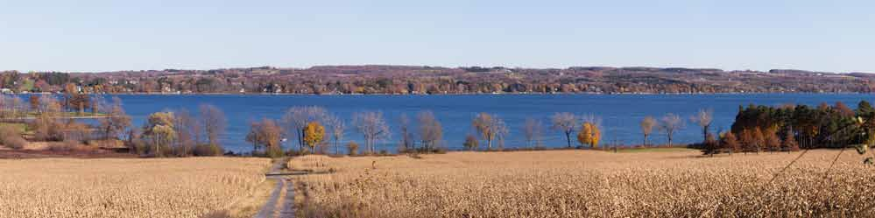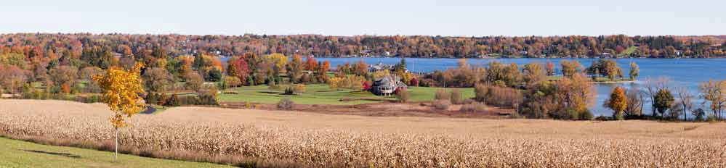Site 1: Route 41A, 1/10 mile south of Andrews Road intersection, looking east

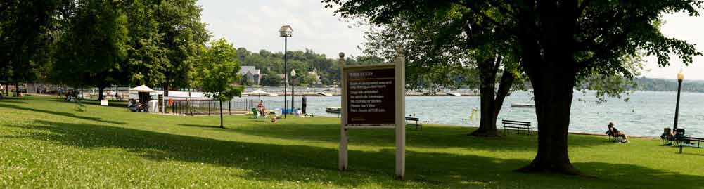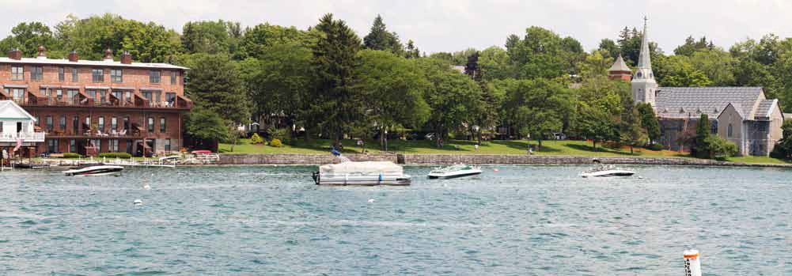Site 2: Clift Park, looking east

Site 2: Skaneateles Lake, taken from end of Skaneateles pier, looking north

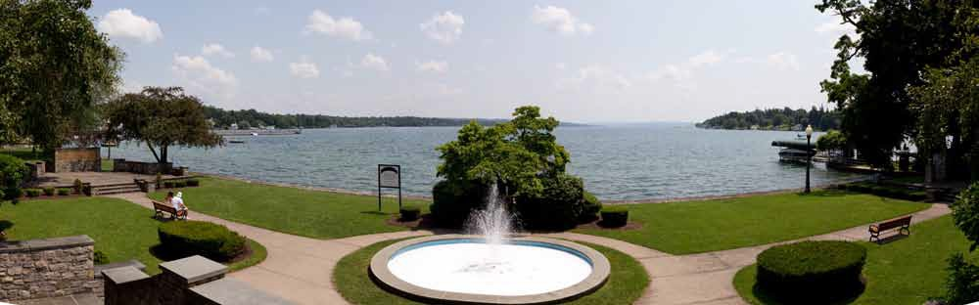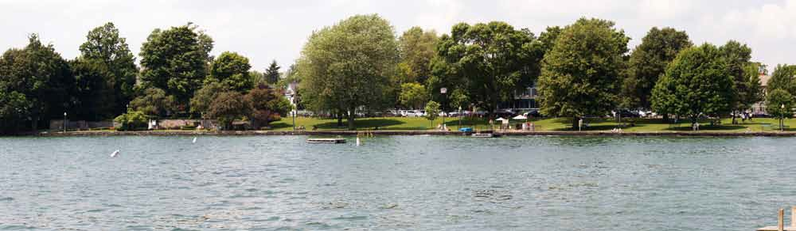Site 2: End of Skaneateles pier, looking north

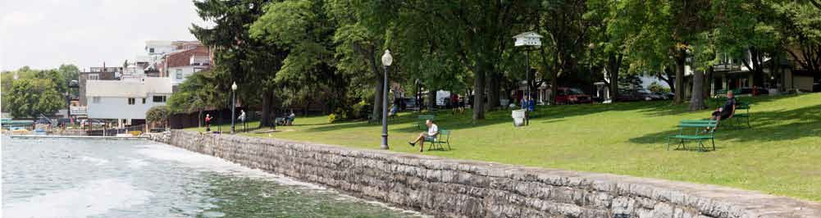Site 2: View looking west from eastern ridge of Thayer Park

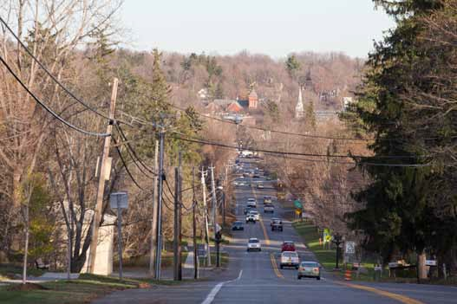

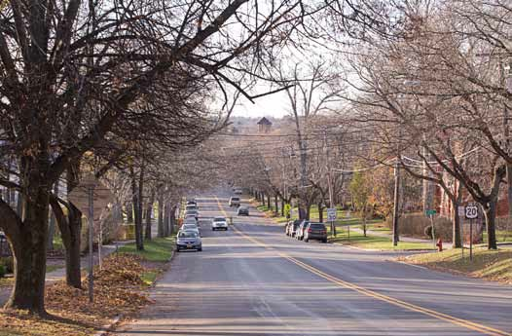
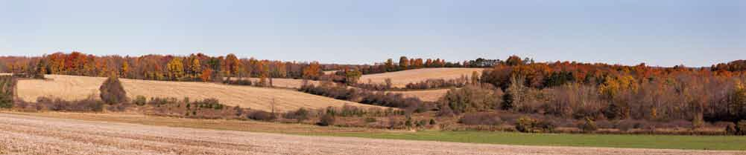Site 3: Route 20, 50 feet west of Onondaga Street intersection, looking west

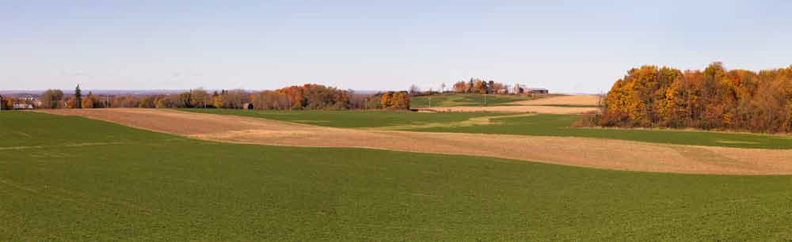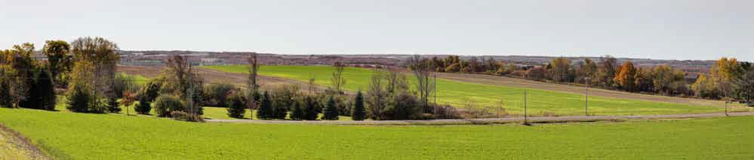Site 5: Giles Road 1/10 mile north of Hencoop Road intersection, looking northeast

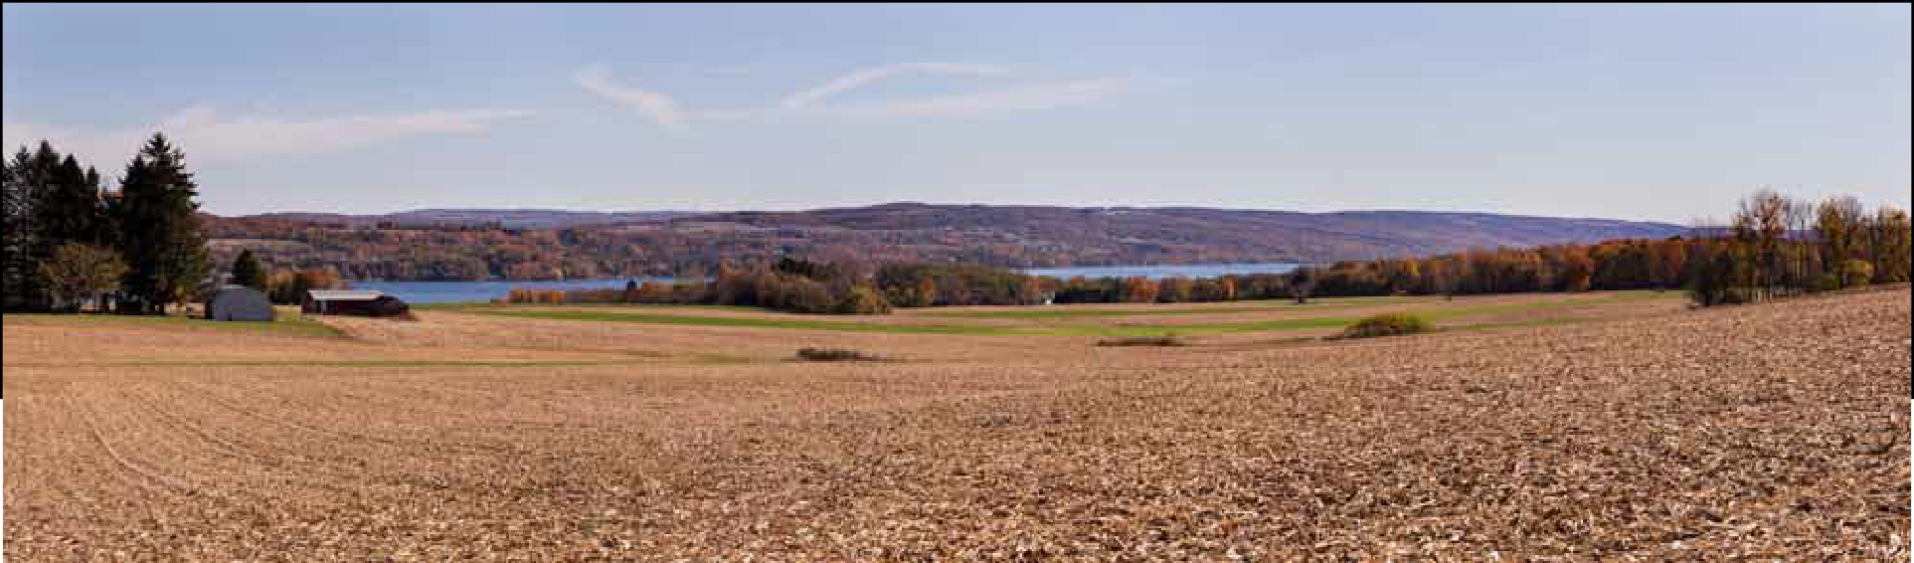Site 5: Weeks Road 150 feet south of Hencoop Road intersection, looking southeast

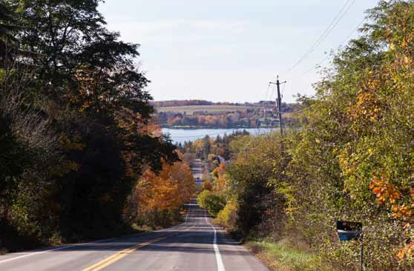
Site 6: Coon Hill Road 3/4 mile from Coon Hill / Route 41 intersection, looking west

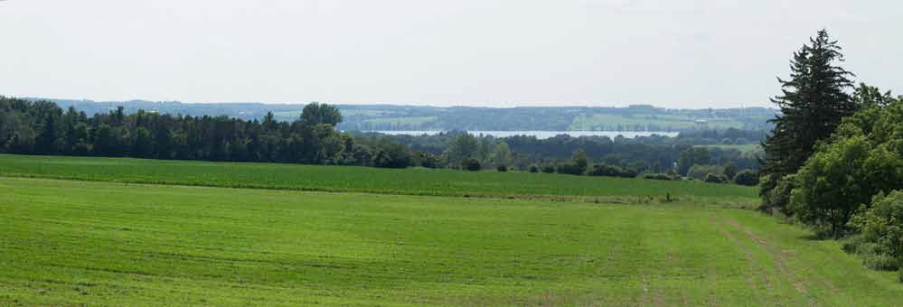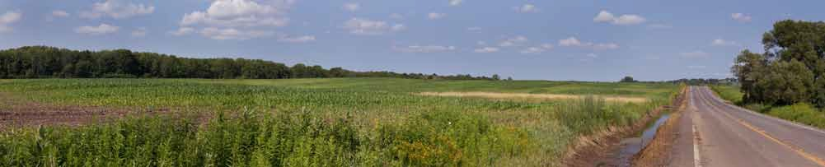Site 7: Rickard Road 425 feet north of Pork Street intersection, looking west

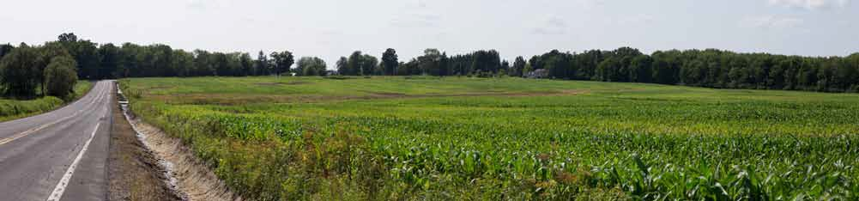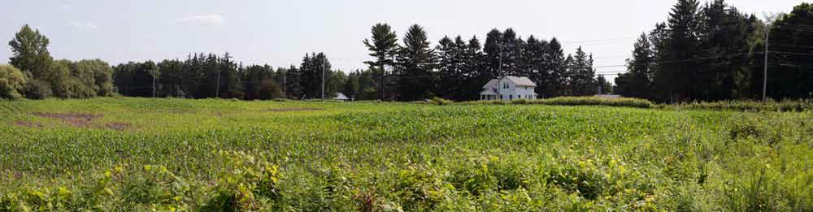Site 8: Pork Street 1/4 mile east of Route 41 intersection, looking northwest

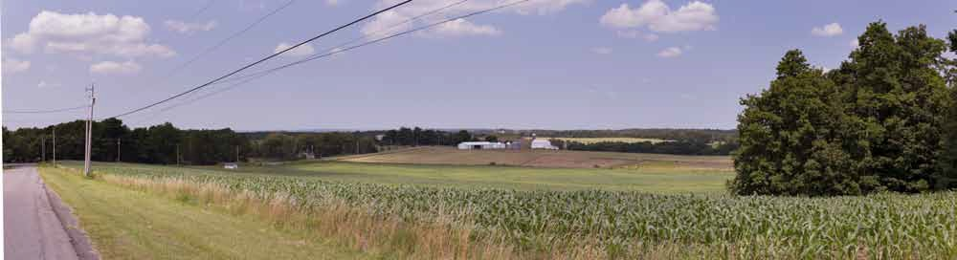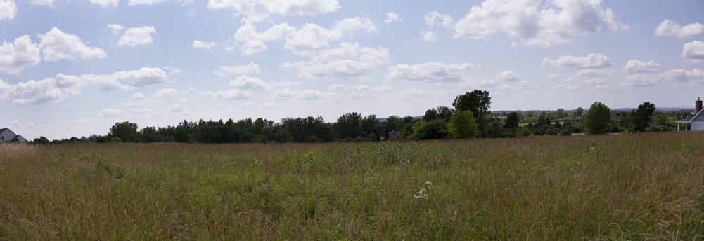Site 10: Highland Ave 1/10 mile south of Old Seneca Turnpike intersection, looking north

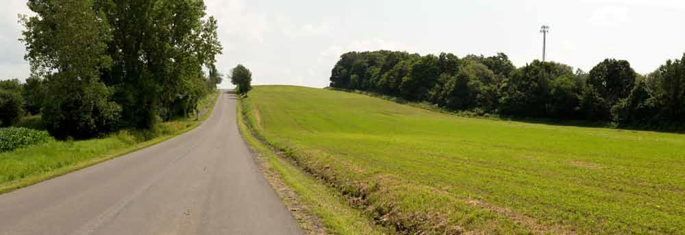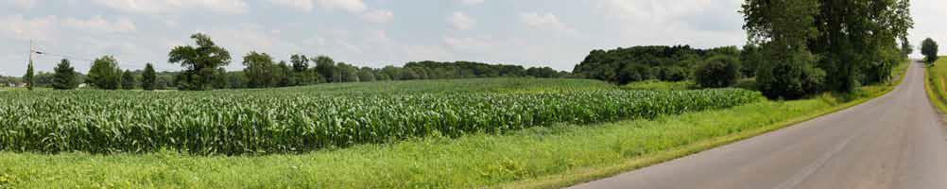Site 11: 500 feet north of County Line Road / Sheldon Road intersection, looking south

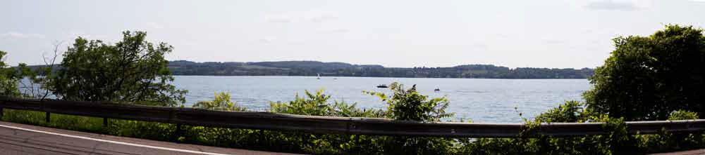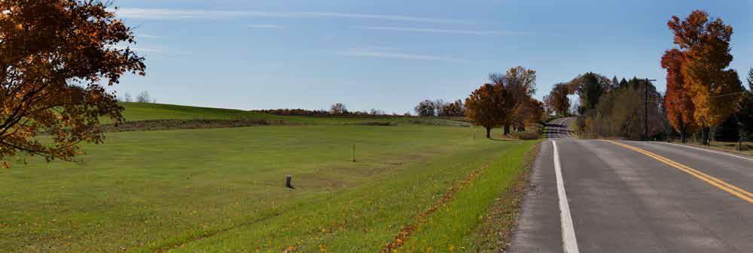Site 12: Route 41 1/2 mile south of Coon Hill Road intersection, looking west

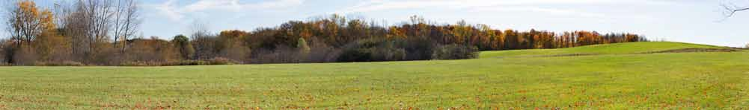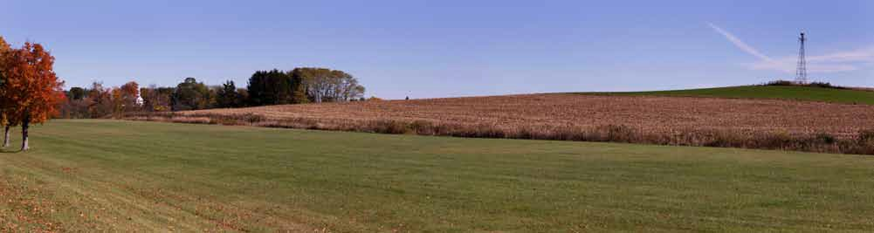Site 13: Benson Road 400 feet southwest of Benson Road / end of runway, looking southeast

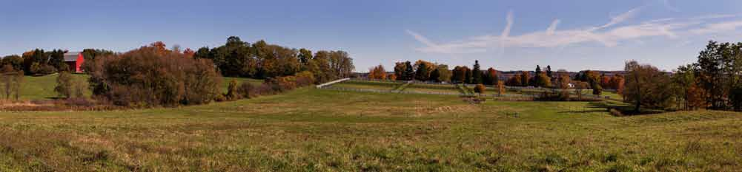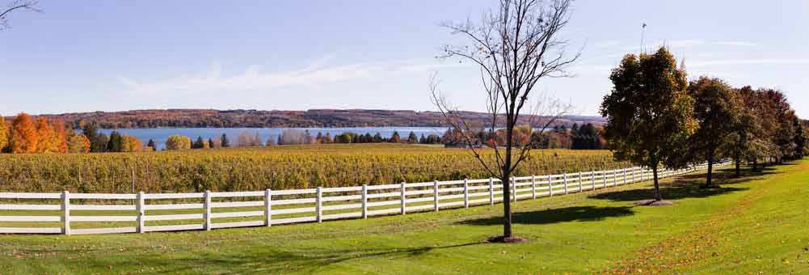Site 13: Benson Road 1/3 mile southeast from Route 41A intersection, looking east

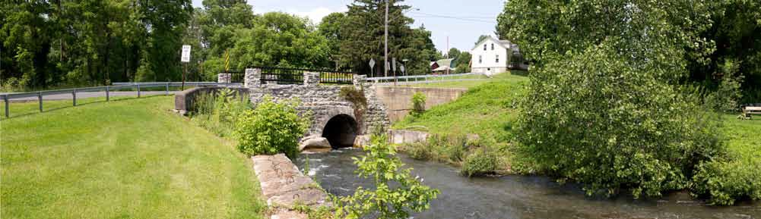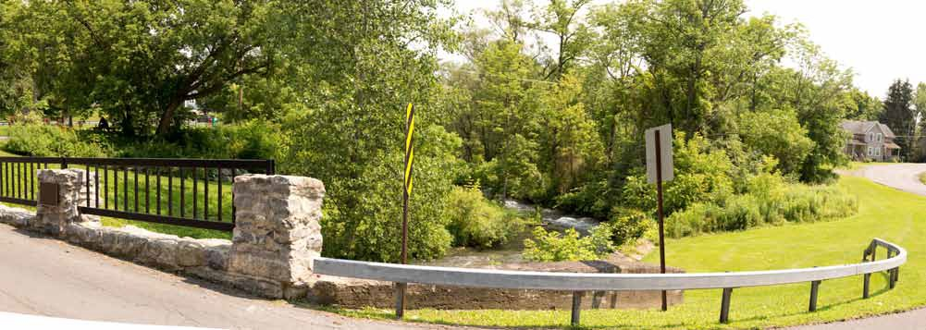Site 14: 75 feet southeast from Crowhill Road bridge, looking northeast

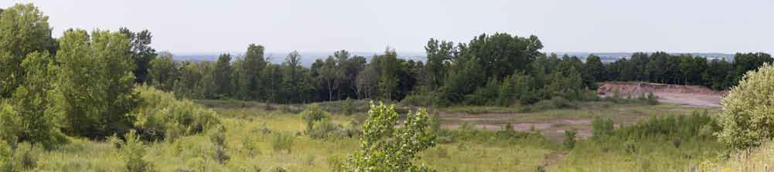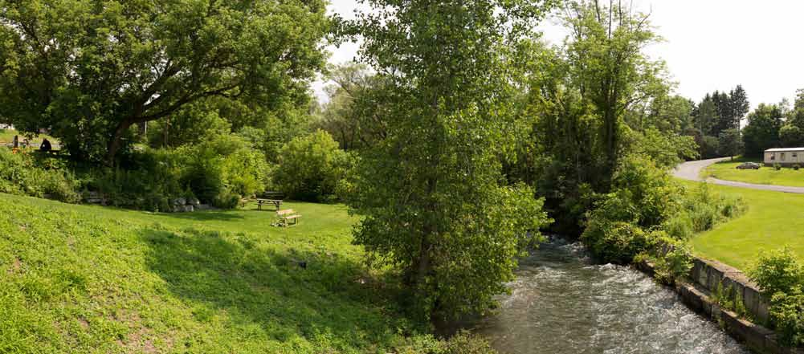Site 14: On Crowhill Road bridge over Skaneateles Creek, looking south

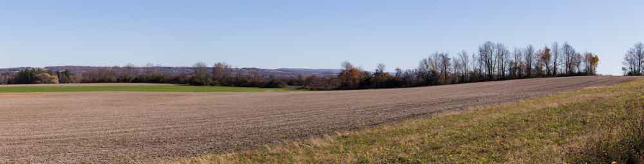

Site 16: South end parking area Hillside Drive (off Route 20), looking southeast

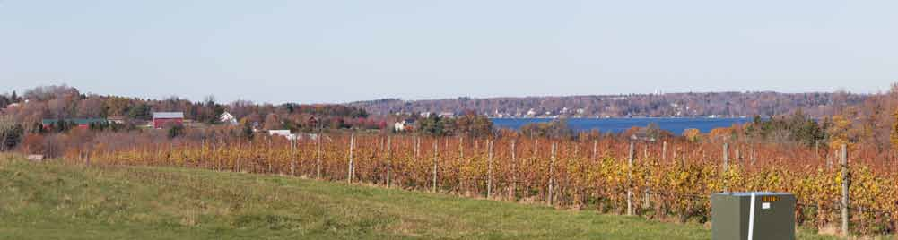

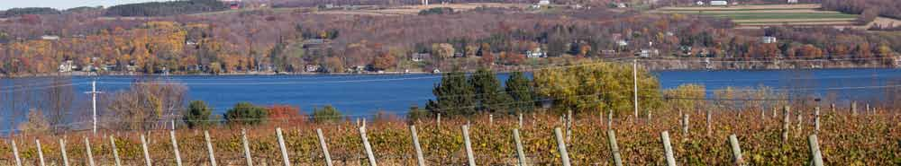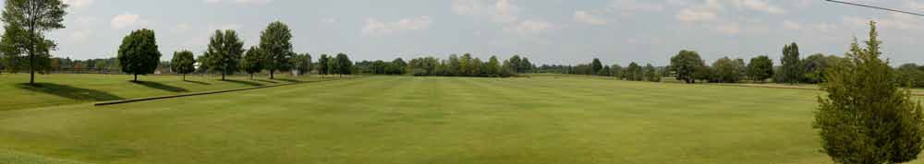Site 19: 1/10 mile from Anyela’s entrance / Route 41A, looking east

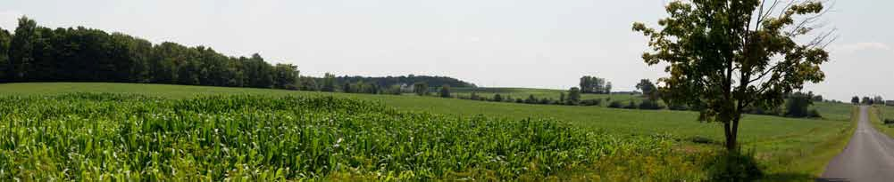Site 20: 1/2 mile west from Route 41A / Andrews Road intersection, looking north

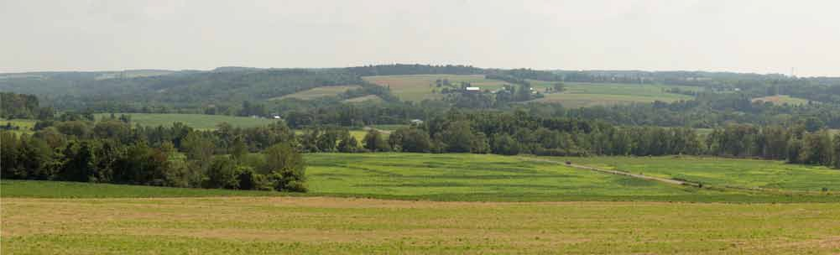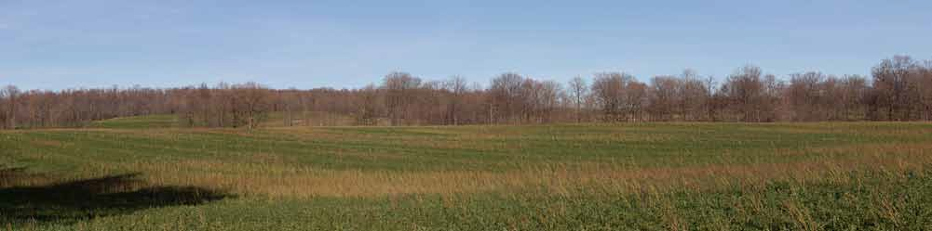Site 21: Southeast corner of forest preserve, looking east-southeast

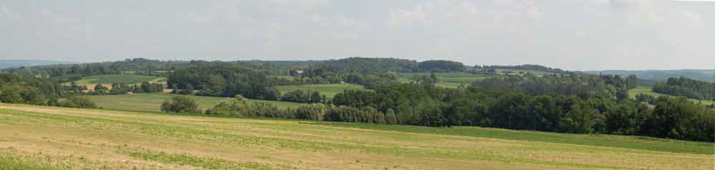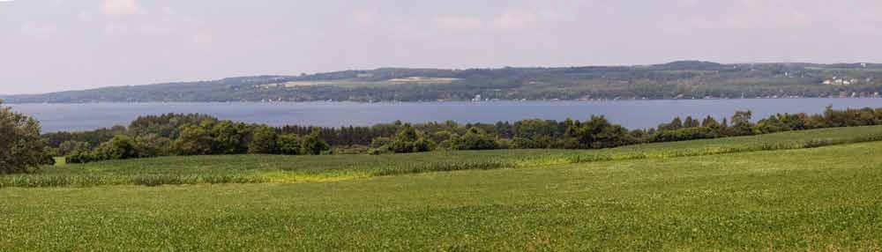Site 22: At split of Lacy Road and Route 359, looking southeast

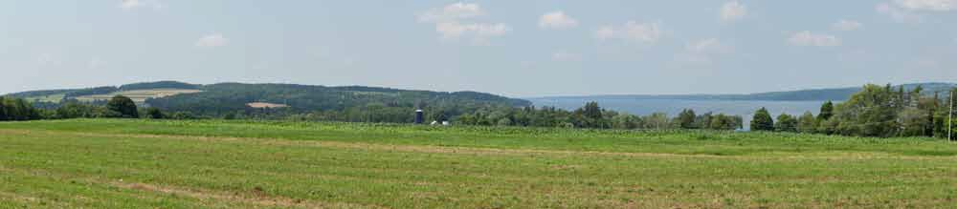

Site 24: Heifer Road 150 feet west of Route 41A intersection, looking north

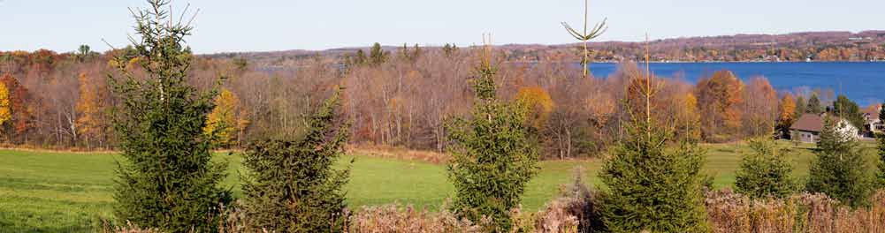

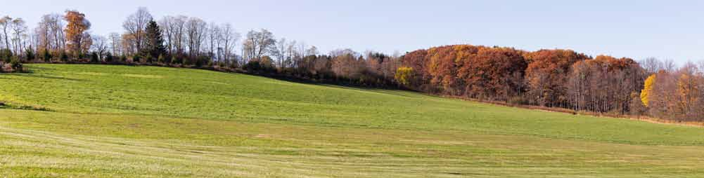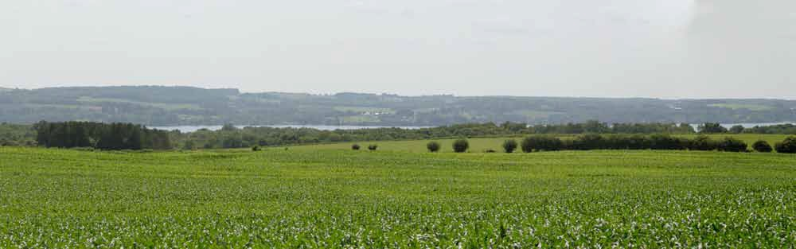Site 25: Firelane 17 550 feet east of Route 41A, looking northwest

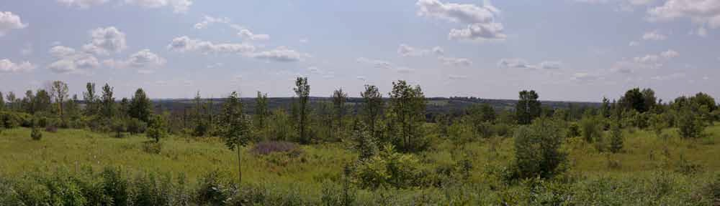Site 27: Observation deck at Skaneateles Conservation Area, looking west

